Biosolids Tool (BST)
User’s Guide
Version 1
February 2023

Scope and Purpose
Biosolids (also referred to as treated sewage sludge) result from the treatment of domestic sewage in a wastewater treatment facility. When applied to land at the appropriate agronomic rate, biosolids may provide several benefits including nutrient addition, soil structure, and reuse of water. Land application of biosolids also can have economic and waste management benefits (e.g., conservation of landfill space; recycling a waste product reducing the demand on non-renewable resources like phosphorus and the demand for synthetic fertilizers; reduced overall farm cost for fertilizers). In addition to rich organic materials, biosolids can contain contaminants depending on domestic or industrial sources that come into the wastewater treatment facility for treatment. Under the Clean Water Act (CWA), contaminants in effluent discharges to surface waters are controlled by the National Pollutant Discharge Elimination System (NPDES) permits. Section 405(d) of the CWA requires the Environmental Protection Agency (EPA) to “Establish numeric limits and management practices that protect public health and the environment from the reasonably anticipated adverse effects of chemical and microbial pollutants during the use or disposal of sewage sludge.”
EPA developed the Biosolids Tool (BST) for a specific purpose: to support the EPA’s assessment of risk associated with contaminants identified in biosolids and to identify contaminants that are not likely to pose risks to humans or the environment if they occur in land applied biosolids. In the biennial review process under Section 405(d) of the CWA, EPA identifies compounds reported to occur in biosolids based on a review of available public literature. The BST was designed to efficiently and effectively evaluate the risk of pollutants identified in Biennial reviews using conservative assumptions of exposure and toxicity. EPA is proposing to use the BST to evaluate the potential human health and ecological risks from land application and surface disposal of biosolids. The BST evaluates the potential risk of individual chemical contaminants in biosolids to a farm family and to aquatic and terrestrial organisms in the vicinity of the biosolids application/disposal. If a pollutant passes an initial screen, it will be deemed low priority. If a pollutant fails the initial screen, indicating potential risk to human health and/or the environment, EPA will determine whether an additional higher-tier (probabilistic) assessment is needed to further assess potential risks. Based on the higher-tiered assessment, EPA will determine if regulation under the CWA is appropriate.
All models have limitations that must be understood to properly parameterize the inputs and to understand the outputs. The BST uses a broad range of information from chemistry, environmental fate and exposure science, and toxicity; you must have a sufficient understanding of all these areas to generate meaningful risk estimates. The last section of this User’s Guide lists limitations that you should be aware of in general, but this is not a complete listing of model limitations that may apply to the range of chemicals that occur in biosolids. This tool was developed mainly for screening risk assessments, but it is essential that you properly parameterize the model to obtain high-end exposures.

Acknowledgements
The EPA gratefully acknowledges Robert Brobst, P.E., for his contributions to plant-available nitrogen (PAN) calculation methodology and the use of the Colorado Department of Public Health & Environment’s PAN and agronomic spreadsheet calculation tool (CDPHE, 2018), which was used as described in Appendix E to validate the application rates used in the Tool.
The EPA also thanks scientists and staff at Research Triangle Institute (RTI), who developed this tool and associated User’s Guide. (EPA Contract NO. 68HERC20D0019 Task Order: PR-OW-20-00582.

Table of Contents
Scope and Purpose ii
Acknowledgements iii
Table of Contents iv
List of Figures v
1. Introduction 1
1.1 Overview of the Biosolids Tool 1
1.2 Organization of this User’s Guide 5
2. Install and Launch the Biosolids Tool 6
3. Configure an Analysis 9
3.1 Configure Modeling Scenarios and Site Parameters 9
3.1.1 Configure an LAU 10
3.1.2 Configure a Surface Disposal Unit 11
3.2 Configure Chemicals 11
3.2.1 Select Chemicals to Include in a Simulation 12
3.2.2 Add New Chemicals 12
3.2.3 View, Edit, and Delete Chemicals 18
3.2.4 Compare Non-default Properties for Selected Chemicals 24
3.3 Configure Human Exposure 25
3.4 Configure Ecological Exposure 26
3.5 View Inputs 27
4. Run a Simulation 32
5. View, Export, and Save Results 33
5.1 View Results 33
5.2 Export Results and Associated Inputs 36
5.3 Save a Run 36
6. Limitations 38
7. References 40
Appendices
A Technical Background
B Non-Chemical-Specific Parameters
C Chemical-Specific Parameters
D Human and Ecological Toxicity Values
E Validation and Sensitivity Analyses

List of Figures
Figure 1. Conceptual model of human exposure from land application of biosolids. 2
Figure 2. Conceptual model of human exposure from surface disposal of biosolids. 2
Figure 4. Overview of Biosolids Tool modeling environment. 4
Figure 3. Conceptual model of exposure to aquatic and terrestrial wildlife from land applied biosolids. 4
Figure 5. Biosolids Tool limitations disclaimer. 7
Figure 6. Biosolids Tool Main Menu. 7
Figure 7. Configure Model window, showing the top of the Scenarios tab. 9
Figure 8. Configure Model window, showing the bottom of the Scenarios tab with both LAU and surface disposal selected. 10
Figure 9. Chemicals tab: select chemicals, view and modify properties, add new chemicals, and compare properties. 11
Figure 10. Add New Organic Chemical window. 13
Figure 11. Add New Inorganic Chemical window. 14
Figure 12. Chemical Properties screen header: in (A) View mode for a built-in chemical, (B) Edit mode for a built-in chemical, and (C) View mode for a user-added chemical (Delete Chemical button visible). 18
Figure 13. Chemical/Physical Properties tab. 21
Figure 14. Chemical Properties window: view or edit ecological BAFs. 22
Figure 15. Chemical Properties window: view or edit ecological toxicity values. 23
Figure 16. Chemical Property Comparison window. 24
Figure 17. Human Exposure tab: Select one or more pathways to run. 25
Figure 18. Ecological Exposure tab: Select one or more. 26
Figure 19. View/Edit Receptor Diet form. 27
Figure 20. Inputs tab: Scenario inputs. 28
Figure 21. Inputs tab: Fate and transport inputs. 29
Figure 22. Inputs tab: Chemical inputs. 29
Figure 23. Inputs tab: Human exposure factors. 30
Figure 24. Inputs tab: Ecological exposure factors. 30
Figure 25. Inputs tab: Ecological bioaccumulation factors. 30
Figure 26. Inputs tab: Ecological toxicity values. 30
Figure 27. Results window showing LAU results. 33
Figure 28. Sample export file. 36

1. Introduction
The Biosolids Tool (BST) is a multimedia, multipathway, multireceptor deterministic, problem formulation, and screening-level model that can estimate high-end human and ecological hazards based on potential exposures associated with land application of biosolids or placement of biosolids in a surface disposal unit. The results can be used to identify pollutants, pathways, and receptors of greatest interest and to inform decisions about the need to perform more refined modeling or to address data gaps or uncertainties.

1.1 Overview of the Biosolids Tool
The Biosolids Tool leverages the existing modeling framework of the probabilistic multimedia, multipathway, multireceptor methodology (3MRA) that has been used by the EPA’s Office of Water (OW) to conduct biosolids risk assessments. This modeling framework is consistent with approaches applied in other EPA offices (such as the Office of Resource Conservation and Recovery. the Office of Pesticide Programs, and the Office of Research and Development), including the Science Advisory Board–reviewed 3MRA methodology (U.S. EPA, 2003b), the Variable Volume Water Model (VVWM), and the Human Health Risk Assessment Protocol (HHRAP, U.S. EPA, 2005).
The Biosolids Tool is a simplification of the biosolids modeling framework previously used to refine biosolids risk assessments. BST is a multipathway deterministic model that uses high-end inputs for exposures for four scenarios (three land-application scenarios and one surface-disposal scenario):
- Crop: biosolids are land-applied at an agronomic rate to a tilled field used to grow crops for human consumption.
- Pasture: biosolids are land-applied at an agronomic rate to an untilled field used to pasture beef and dairy cattle raised to produce beef and milk for human consumption.
- Reclamation: biosolids are land-applied at a higher rate suitable for a mining reclamation site that is subsequently used as a pasture for beef and dairy cattle.
- Landfill: biosolids are surface disposed in a landfill. Three landfill liner options are available: no liner, clay liner, or composite liner.
This section presents the conceptual models for the BST, simplified representations that show how pollutants in biosolids move in the environment, from their release and transport through various environmental compartments, to human and ecological receptors coming in contact with or consuming environmental media (e.g., groundwater, soil) or dietary items (e.g., milk, produce).
Figure 1 depicts the land application conceptual model which includes two waterbodies: a farm pond, from which the farm family catches fish and where ecological receptors live and feed, and an index reservoir, which is a source of drinking water. The surface disposal conceptual model, Figure 2, does not include these waterbodies.
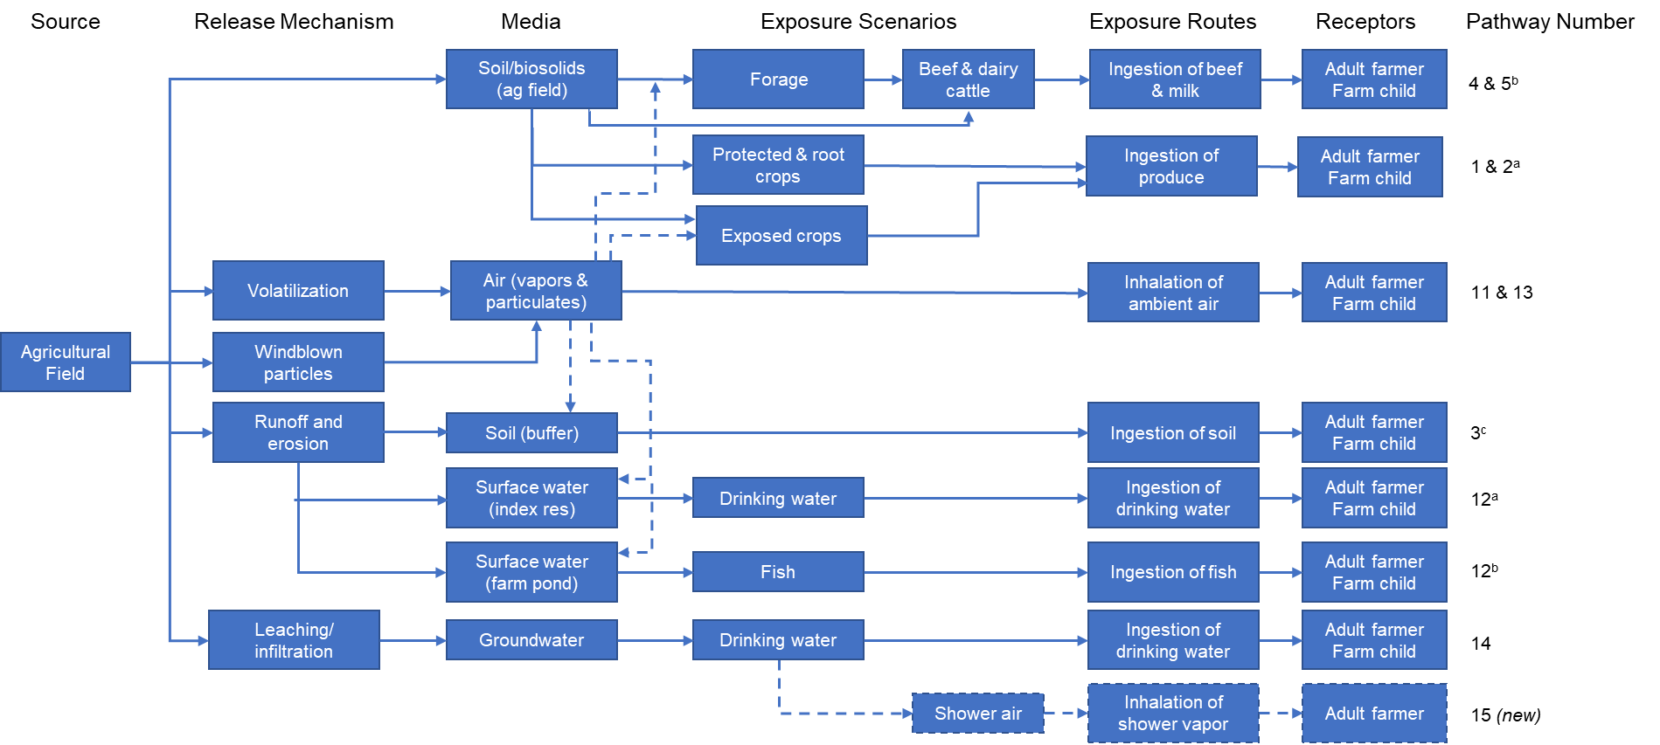
Dashed arrows and box outlines indicate a pathway or route that has been added since 1992.
ª Originally, Pathways 1 and 2 differed only in that they were modeled for two different scenarios (1, general population and 2, home gardener). In the current model, this pathway is modeled for only one scenario, a farm family (adult farmer and farm child).
^{b} Originally, Pathways 4 (cattle eat contaminated plants) and 5 (cattle eat contaminated soil) were modeled separately. In the current model, these pathways have been combined to reflect that when cattle eat forage, they ingest soil as well. The overall cattle diet is assumed to be 95% forage and 5% soil.
^{c} Originally, Pathway 3 modeled a receptor eating soil/biosolids from the field where biosolids are applied. In the current model, the receptors are assumed to eat soil from the buffer, following erosion and runoff from the field.
Figure 1. Conceptual model of human exposure from land application of biosolids.

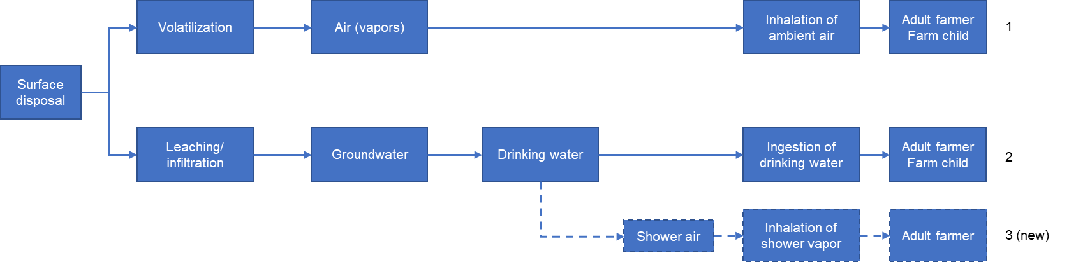
Figure 2. Conceptual model of human exposure from surface disposal of biosolids.
- For the crop scenario, the human receptors are an adult farmer and farm child. This farm family is assumed to live on a farm and consume farm-raised foods where land-applied biosolids is used annually as a fertilizer or a soil amendment, and thus they are more highly exposed to biosolids than the general population. Eight pathways of human exposure are considered. The farm family’s diet includes a significant portion of home-produced foods, including produce, beef and milk, and fish from a farm pond. The family’s primary source of drinking water is a shallow well (ground water); a nearby reservoir (surface water) serves as a secondary source. Non-dietary exposure pathways include inhalation of ambient air and particulates, inhalation of indoor air while showering with groundwater, and incidental ingestion of dust or soil.
- For the pasture scenarios, the adult and child live near the pasture to which biosolids are applied annually. Eight human exposure pathways are considered: diet only considers beef and milk from exposed animals and fish from a farm pond. The family’s primary source of drinking water is a shallow well (ground water); a nearby reservoir (surface water) serves as a secondary source. Additional exposure pathways include inhalation of ambient air and particulates, inhalation of indoor air while showering with groundwater, and incidental ingestion of soil.
- For the reclamation scenarios the adult and child live near the reclaimed land to which biosolids are applied in a high-end one-time application. Eight human exposure pathways are considered: diet only considers beef and milk from exposed animals and fish from a farm pond. The family’s primary source of drinking water is a shallow well (ground water); a nearby reservoir (surface water) serves as a secondary source. Additional exposure pathways include inhalation of ambient air and particulates, inhalation of indoor air while showering with groundwater, incidental ingestion of soil.
- For the land disposal scenario the human receptors are an adult and a child who live adjacent to the landfill and to obtain their drinking water from a shallow well. Groundwater quality is impacted by the landfill. Three human exposure pathways are considered: ingestion of groundwater, inhalation of indoor air while showering with groundwater, and inhalation of ambient air and particulates.
The reservoir and farm pond are the standard waterbodies simulated in the VVWM, used to estimate pesticide concentrations in surface water following pesticide application to the field (U.S. EPA, 2019; 2020); see Section A.2.2.2 for more description. The default meteorological input represents an average climate; however, the BST can be run for three different climatic types: an average climate, a wet climate, and a dry climate (Appendix A).
Figure 3 shows the conceptual model that describe how contaminants in biosolids can move from the land application or disposal site to terrestrial and aquatic ecological receptors. The ecological receptors considered in the three land application scenarios are: invertebrate and vertebrate animals and plants exposed in cropland, pasture, reclaimed land and in the farm pond. In the land application scenarios, four terrestrial exposure pathways are considered: ingestion of contaminated plants (mammals/birds/cattle); ingestion of contaminated insects (mammals/birds); exposure to terrestrial plants; and exposure to soil invertebrates. Five aquatic exposure pathways are considered: aquatic exposure to fish; aquatic exposure to amphibians (aq community); aquatic exposure to aquatic plants; sediment exposure to aquatic invertebrates; and ingestion of contaminanted fish (aquatic dependent mammals/birds). No ecological receptors are modeled in the landfill scenario.
For more details on the configuration of these scenarios please see Appendix A.

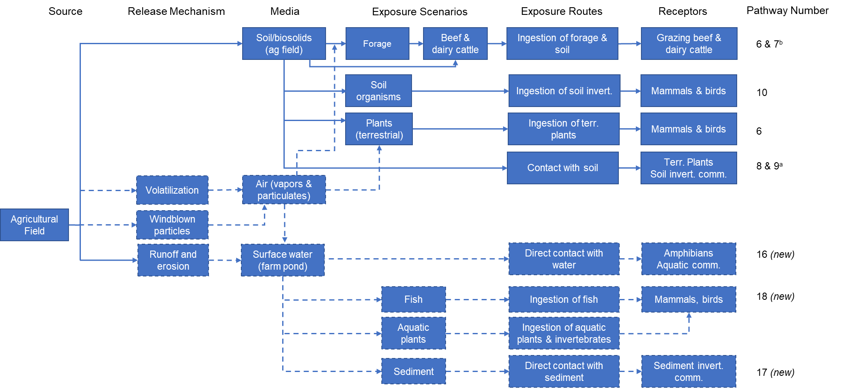

Dashed arrows and box outlines indicate a pathway or route that has been added since 1992.
ª Pathway 8 is terrestrial plants, and Pathway 9 is soil organisms.
^{b} Originally, Pathways 4 (cattle eat contaminated plants) and 5 (cattle eat contaminated soil) were modeled separately.
In the current model, these pathways have been combined to reflect that when cattle eat forage, they ingest soil as well. The overall cattle diet is assumed to be 95% forage and 5% soil.
Figure 4. Overview of Biosolids Tool modeling environment.
Figure 3. Conceptual model of exposure to aquatic and terrestrial wildlife from land applied biosolids.
Within the Biosolids Tool, source, fate and transport, and exposure and risk models are linked, and input and output data transfers are automated. Figure 4 presents an overview of how these components are integrated.
The Biosolids Tool runs the biosolids modeling framework in deterministic mode to characterize high-end exposures. This is achieved by setting key parameters to high-end values in the associated database:
- Chemical concentration in biosolids is set to the 95th percentile concentration for each chemical monitored in the TNSSS (U.S. EPA, 2009a, b; 2021) plus a few emerging constituents of interest in biosolids. The data development process for chemical-specific data is described in Appendix C (all properties other than toxicity data).
- Biosolids Application Rate: For the crop and pasture scenarios, the default dry application rate is 10 MT dry weight/ha-application applied once a year for 40 years (see Appendix E). For the reclamation scenario, the default dry application rate is 40 MT dry weight/ha applied one time (see Appendix E)
Consumption Rates are set to the 90th percentile based on the most current EPA guidance on exposure: the 2011 Exposure Factors Handbook (U.S. EPA, 2011) (which also incorporates information from the 2008 Child-Specific Exposure Factors Handbook) and individual chapter updates issued in 2017 through 2019; see Appendix B for more details. EPA uses the 90th percentile exposure as a reasonable high-end estimate in assessments under the CWA (https://www.epa.gov/wqc/human-health-water-quality-criteria-and-methods-toxics#methodology)
The BST also requires a variety of environmental setting parameters, which were set to central tendency values (e.g., median, where available) rather than high-end values to reduce the likelihood of results being overly conservative. Environmental setting parameters are represented by median values selected from either regional data associated with one of three climatic stations or from national distributions. Appendix B provides additional information about non-chemical- specific parameters.
Finally, data development for toxicity data for both human and ecological exposures is described in Appendix D.

1.2 Organization of this User’s Guide
This User’s Guide is organized as follows:
- Section 2: Install and Launch the Biosolids Tool
- Section 3: Configure an Analysis. In addition to describing how to select chemicals, pathways, and receptors to run, this section also describes how to add chemicals and how to modify chemical and selected fate inputs.
- Section 4: Run a Simulation
- Section 5: View, Export, and Save Results
- Section 6: Limitations
Section 7: References.
Throughout this User’s Guide are blue text boxes that draw your attention to a particularly important piece of information. Please be sure to read those.
In addition, the User’s Guide includes the following appendices:
- Appendix A describes the technical formulation of the Tool in more detail
- Appendix B documents the non-chemical-specific inputs
- Appendix C documents the development of chemical-specific inputs (except human health and ecological toxicity values)
- Appendix D documents the development of human health and ecological toxicity values
- Appendix E documents various validation and sensitivity analyses.

2. Install and Launch the Biosolids Tool
The Biosolids Tool is an Access database with a graphical user interface that calls the biosolids modeling framework to run in deterministic mode. You must have Microsoft Access 2013 or later to run the Biosolids Tool. To install the Tool,
System Requirements
Operating System: Windows 7 or later. MS Access: any 32- or 64-bit installation of Access 2013 or later.
- Copy the BST_v2022xxxx.zip file to your computer (where xxxx is the date of release).
- Double-click on the zip file to open it.
- Click on Extract.
- Select a folder you have read/write access to as the path to extract to (for example, your My Documents folder).
- Click Ok.
- If updating a previous installation, when it asks if it should overwrite, click on Yes to All.
- Close the zip file.
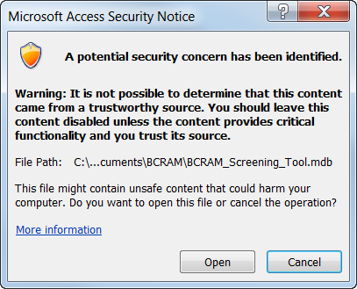
The Tool will be installed in [your_folder]\BST. Please note that the length of this install folder path cannot exceed 48 characters; if it does, the Tool will generate all zero results when run.
To launch the Biosolids Tool, double-click the file BST_v2022xxxx.mdb in the BST folder in the location you extracted the files to.
Depending on your Access Trust Center settings, you may see the security warning at right whenever you open the Tool. This is a standard Access warning, and you can safely click on Open. You can eliminate this warning by making the location where you saved the Tool a Trusted Location in Access.
You may also see the following security warning the first time you run the Tool:
Click on the Enable Content button. If you do not, the Tool will not run. This is also a standard Access security feature, but it should not persist after the first time you run the Tool and enable content.
When you open the Tool, it displays the limitations warning shown in Figure 5, which is a briefer version of the limitations described in the front matter. From this screen, you can click on a link to this User’s Guide or click on the Continue button to reach the Main Menu, which is shown in Figure 6. The version number is displayed in the title bar at the top of the Main Menu window. From the Main Menu, you can configure an analysis, run it, and then view the results. Those activities are described in the following sections.
Most screens have a Help icon (a question mark in a blue box; see upper right corner of Figure 5); click on that to bring up a PDF of the relevant section of this User’s Guide.
                - 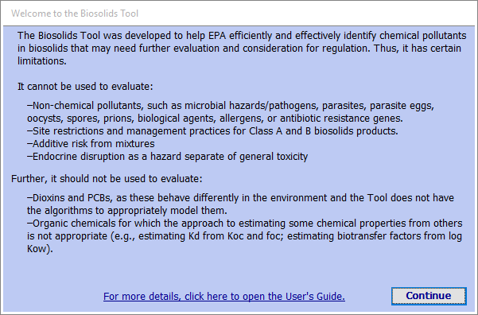
Figure 5. Biosolids Tool limitations disclaimer.
                - 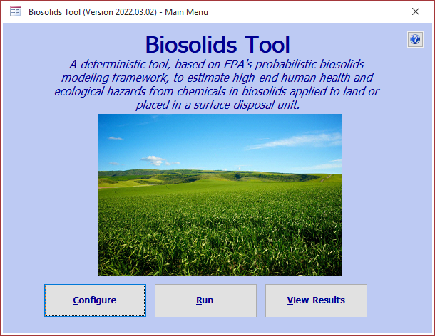
Figure 6. Biosolids Tool Main Menu.
A Note about Scroll Bars in the Biosolids Tool
The Configure and View Results windows of the Tool use nested forms to display multiple tabs within the window and sometimes subtabs within the tabs. Each nested level has its own set of vertical and horizontal scroll bars if the data in that level do not all fit on the screen at once. This can become confusing when there are three nested layers, as here:
                - 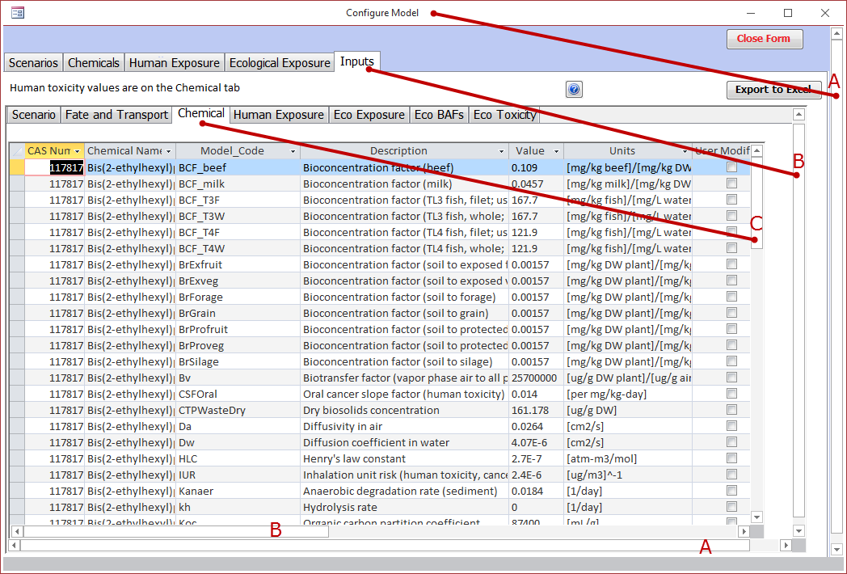
Here, the Configure Model window contains five tabs, and the last tab, Inputs, contains seven subtabs. The outermost scroll bar (A) controls the top level window (here, the Configure Model window). The next one in (B) controls the next nested level (here, the Inputs tab). Finally, the innermost scroll bar (C) controls the most detailed nested level (here, the Chemical Inputs subtab). So you will mostly use the innermost vertical scroll bar to scroll through long lists of options.
You will typically only need the other vertical scroll bars when you are viewing a screen where the data are too wide to fit on the screen at once (the Inputs tab, shown above, and the View Results windows). In those instances, you may not be able to see the innermost horizontal scroll bar (as above, where only the A and B horizontal scroll bars are visible at first). Then, you will need to scroll the next vertical bar out (B) all the way to the bottom to display the innermost (C) horizontal scroll bar (below, left). You can then use the C scroll bar to scroll to the right to see more columns (below, right). Note that the titles at the top of the columns have scrolled off screen, so once you scroll right, you may want to scroll back up using the B scroll bar until they appear again.
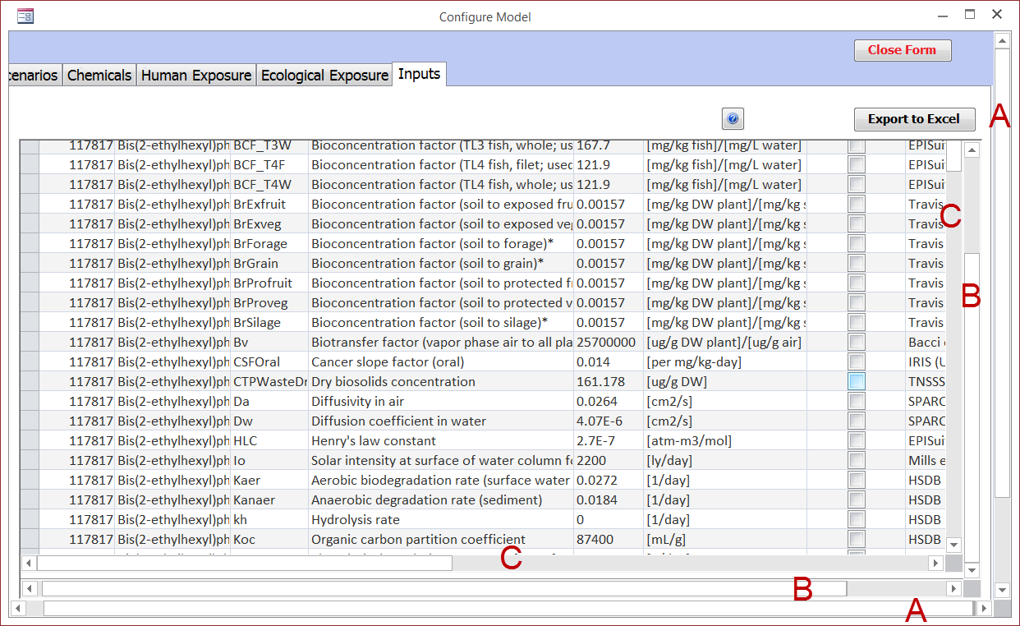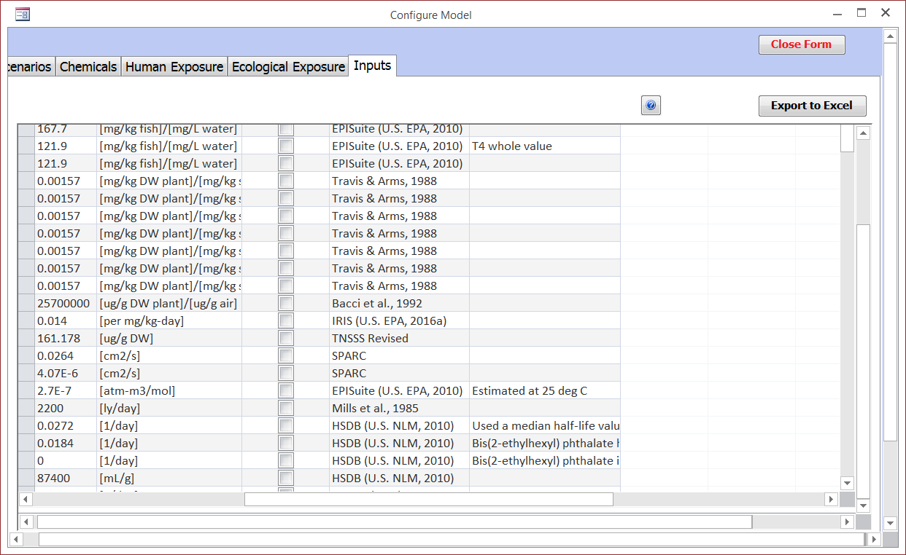

3. Configure an Analysis
To configure an analysis, click on the Configure button on the Main Menu (Figure 5). This will open the Configure Model window, shown in Figure 7. This window has four tabs on which you can select configuration options and one where you can view the selected inputs. These are described in the rest of this section. It is not necessary to visit all the tabs, only those on which you wish to change configuration options. You can close the Configure Model window and return to the Main Menu at any time from any of the tabs by clicking the Close Form button in the upper right corner of the form or by clicking on the × (close window icon) in the upper right corner of the window (next to the minimize and resize icons).
IMPORTANT! Any configuration changes you make are automatically saved in the underlying database, including changes to selected scenarios, chemicals, pathways, and receptors; and any changes you make to any inputs. The next time you run the Tool, those settings will be the starting point for any configuration changes you might then make.
See Section 5.3 for a discussion of how to save a version of the Tool with such changes while retaining an original version; you will need to prepare to do this BEFORE you change any configuration values.
                - 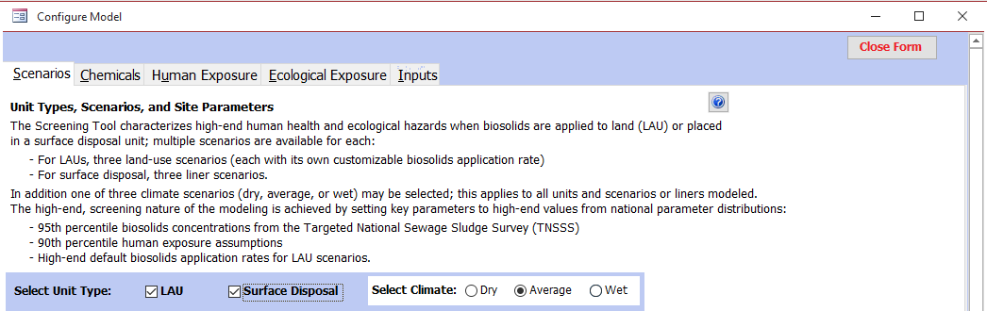
Figure 7. Configure Model window, showing the top of the Scenarios tab.

3.1 Configure Modeling Scenarios and Site Parameters
Figure 6 shows the top part of the Scenarios tab, where you can select unit types and climate. You can run one or both unit types in a single run. However, only one climate can be selected for a model run and will apply to all selected unit types and scenarios. The default climate is average precipitation, but you can select wet or dry options instead (corresponding to high or low precipitation).
Figure 8 shows the bottom portion of the Scenarios tab, where you can set additional options for LAUs (top, green border) and surface disposal units (bottom, blue border). If a unit type is not selected at the top of the screen, the controls in the corresponding section of the screen (check boxes, data entry boxes, and buttons) will be greyed out to indicate they are not active. Both unit types are selected in Figure 7. These options are described in the next subsections.
                - 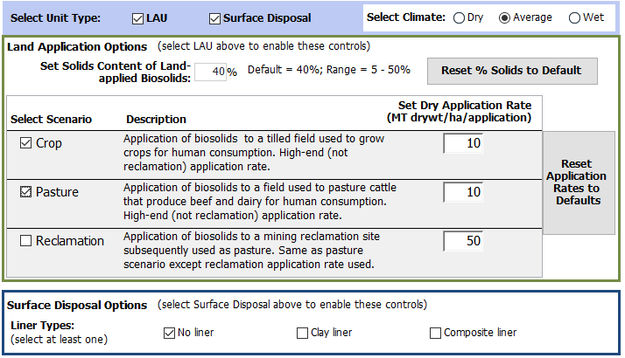
Figure 8. Configure Model window, showing the bottom of the Scenarios tab
with both LAU and surface disposal selected.

3.1.1 Configure an LAU
For the LAU, you can set the solids content of biosolids, select application scenarios, and set the dry application rate for each scenario.
The default solids content of biosolids is 40%. You can change this to any value between 5 and 50% by clicking in the text box and entering the desired value. This will change the reference for this parameter to “User Supplied.” While you can later change the value back to 40%, the reference will remain “User supplied” unless you click on the Reset % Solids to Default button (which sets the value to 40% and restores the original reference for that value). The model is insensitive to changes in percent solids, as it is used only to estimate the incremental infiltration due to the water content of the biosolids. This value will be applied to all scenarios for the LAU, but does not affect the surface disposal unit, which defaults to 10% solids and cannot be modified.
Select or deselect application scenarios to run by clicking the check box to the left of each one. In Figure 7, Crop and Pasture are selected. Clicking an empty check box selects the scenario and clicking a checked check box deselects it. You can select as many as you want, but you must select at least one. The scenarios are described in Section 1.
Set the dry application rate for each selected scenario. The defaults are 10 MT dry/ha-appl for crop and pasture and 50 MT dry/ha-appl for reclamation, but these can be changed if you have site- or scenario-specific values. Regardless of the dry application rate you set, biosolids will be applied at that rate once a year on April 1 for 40 years (for crop and pasture) or one time (for reclamation). The Reset Application Rates to Defaults button to the right of the application rates can be used to reset the values to the defaults.

3.1.2 Configure a Surface Disposal Unit
The only option here is liner type. You can run one, two, or all three in a single run, but at least one must be selected. As noted above, the surface disposal unit uses a percent solids value of 10% for the biosolids (regardless of the value entered for land-applied biosolids), and this cannot be modified.

3.2 Configure Chemicals
Figure 9 shows the Chemicals tab. The pane on the left side of the screen provides various options that operate on all the chemicals or the selected chemicals; these include buttons to change the sort order, select or deselect a batch of chemicals, add new chemicals, and compare chemical properties.
                - 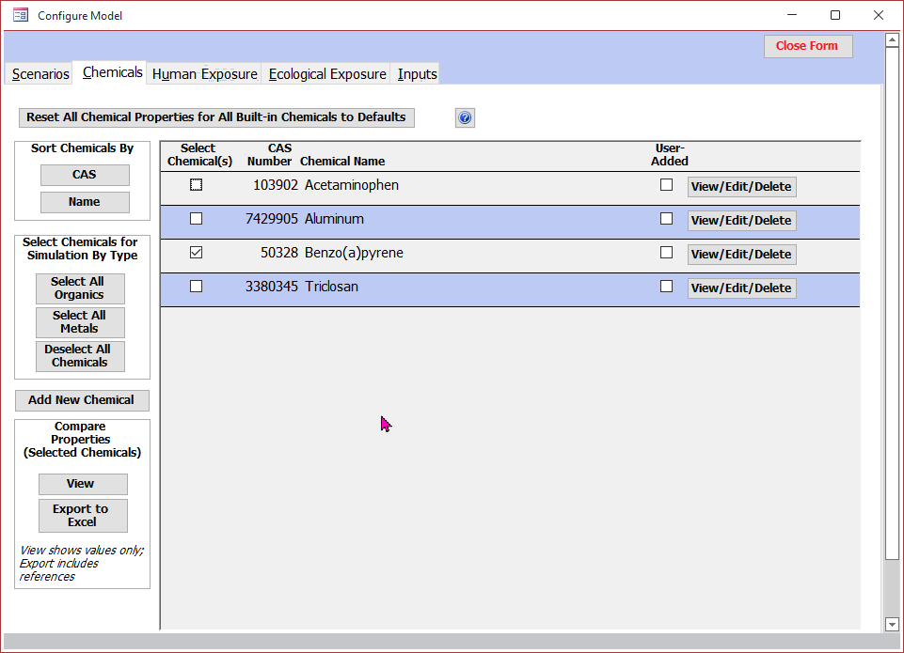
Figure 9. Chemicals tab: select chemicals, view and modify properties,
add new chemicals, and compare properties.
The main part of the screen, at right, provides descriptive information on the available chemicals (CAS number, chemical name, and a ‘user added’ indicator) and two chemical-specific controls: a selection box (to the left of the CAS number) and a View/Edit/Delete button (far right) that brings up the Chemical Properties screen for that chemical, where you can view and edit the chemical-specific data (built-in and user-added chemicals), reset modified values to defaults (built-in chemicals only), and delete chemicals (user-added only). You can also reset any user-modified chemical properties for all built-in chemicals at once by clicking on the Reset All Chemical Properties to Default Values button at the top of the tab. Note this will have no effect on user-added chemicals: those values will not be changed, nor will the user-added chemicals be deleted.

3.2.1 Select Chemicals to Include in a Simulation
To include a chemical in a simulation, use the scroll bar immediately to the right of the column of View/Edit/Delete buttons to scroll through the list of chemicals and find the desired one. Click on the check box under “Select Chemical(s)” to the left of the CAS number. If the box is checked, the chemical has been selected. Click on the checkbox again to deselect it.
The chemical list can be sorted by CAS number or chemical name, as you prefer, using the CAS and Name buttons at the top of the left pane. Chemical names that start with a number are sorted on the first letters, and the number prefix is shown at the end.
If you plan to include all or many of the chemicals available in your run, use the Select Chemicals for Simulation By Type buttons in the middle of the left pane. Click on Select All Organics to select all chemicals designated as organics (without deselecting anything first), and Select All Metals to select all inorganics (also without deselecting anything first). Used in succession, these two buttons will select all chemicals. From there, you can individually deselect any you do not wish to run. Conversely, if you want to run just a few chemicals, use the Deselect All Chemicals button, and then select those you want to run individually.

3.2.2 Add New Chemicals
As mentioned in Section 1.1, the Tool is preloaded with data for some chemicals. You can add additional chemicals to the Tool to supplement the chemicals provided by clicking on the Add New Chemical button in the lower middle of the left pane of the Chemicals tab (Figure 8). To reduce the burden of entering new chemicals, the Add New Chemical forms include only the minimum set of chemical-specific parameters required, omitting others that can be calculated from these required properties (e.g., animal and plant bioconcentration factors from log K_{ow} for organics) or reasonably set to a conservative default (e.g., aquatic degradation rates). Once you have added a new chemical, you will have a chance later to edit any default values.
The inputs differ somewhat for organics and inorganics; therefore, you will be asked which type of chemical you want to enter (Select New Chemical Type window). Click on the appropriate button (or Close Form to cancel and return to the Chemicals tab). Figures 10 and 11 show the entry screens for organics and inorganics, respectively (note that the entire screen as shown in the figures does not all show at once in the Tool; use the vertical scroll bar to see all inputs).
A brief discussion of each of the inputs follows the figures; Appendix C provides a thorough explanation of the data required, sources for these data, and estimation methods for all chemical-specific parameters, both those on the Add New Chemical forms and those omitted from them.
Chemical Limitations of the Biosolids Tool
You should not add dioxin-like compounds (i.e., dioxins or PCBs) to the Biosolids Tool: the fate and transport algorithms contained in the Tool are not appropriate for these compounds. You should also not add mercury compounds. Although the Tool contains the appropriate algorithms for these, they must be combined in a somewhat different way that is beyond the scope of this User’s Guide.
                - 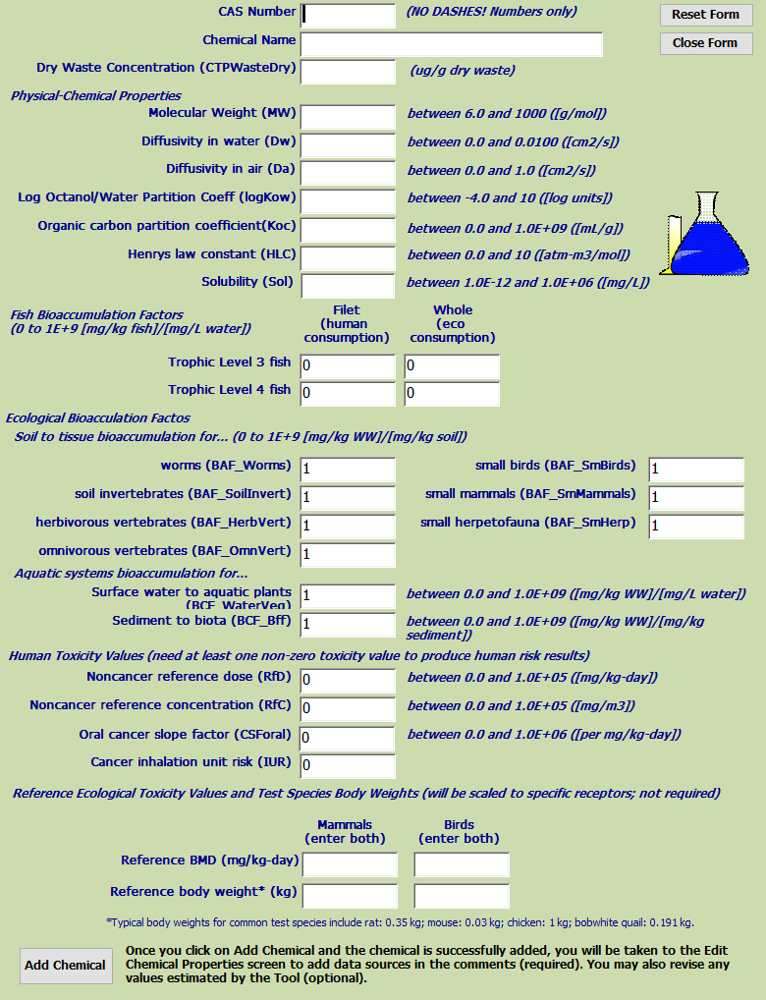
Figure 10. Add New Organic Chemical window.
                - 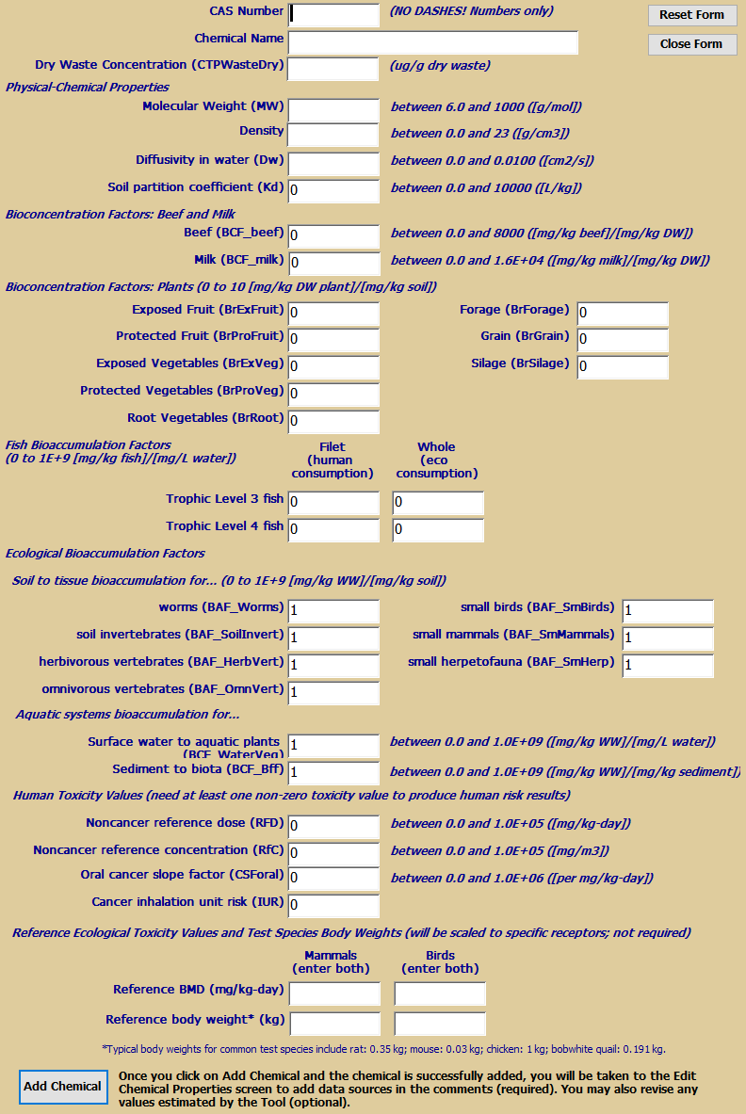
Figure 11. Add New Inorganic Chemical window.
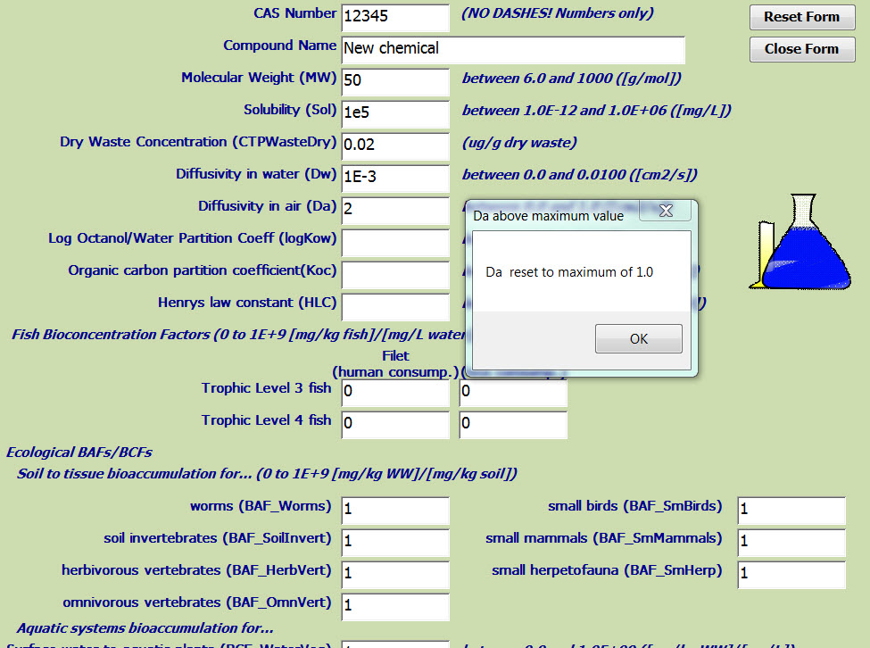
You can move through the fields on the Add New Chemical forms in order using the Tab key or you can skip around by clicking in the desired field. Once you are in a field, however, you must enter a value within the range specified to the right of the value field (or occasionally above, when it applies to multiple grouped entries). The ranges are inclusive (so below, diffusivity in water must be between 0 and 0.01, and can be exactly 0 or 0.01). If you enter a value outside the range, the Tool will reset it to the minimum or maximum when you leave the field, and you will see a warning that this has been done (shown at right). Click on the Ok button to dismiss the warning. You can then either leave the value at the minimum or maximum or, if your entry was a typo and the minimum or maximum is not appropriate, you can correct it. For example, if you entered 2 instead of the actual value 0.2, the reset value of 1 is not appropriate and should be corrected to 0.2.
All of the inputs except chemical name are numeric and can be entered in either standard or scientific notation; scientific notation is not case sensitive (i.e., a value of 34 can be entered as 34, 3.4E+1, or 3.4e+1). Be sure to enter data in the units shown to the right of the allowable range; use of different units will produce erroneous risk results.
Click on the Reset Form button (top right of Add New Chemical form) to clear your entries without saving and start over. Click on the Close Form button (also at top right) to cancel without saving and return to the Select New Chemical Type form.
A few things to note:

General Chemical Information
- CAS number will be saved as all numbers whether you enter it that way or with hyphens.
- Compound name can be any text string, but it may be helpful for purposes of sorting the results by chemical name to move leading numeric prefixes to the end of the name, as follows: “Chlorophenol, 4-” instead of “4-Chlorophenol.”
- Dry waste concentration (CTPWasteDry) must be a dry weight concentration and must be nonzero. If you have only a wet weight waste concentration, divide it by the fractional equivalent of the percent solids you entered on the Scenarios tab. So, for the default solids content of 40%, divide the wet weight by 0.4 to obtain a dry weight.

Physical-Chemical Properties
- Molecular weight (MW) can be derived from the chemical formula if you cannot locate it otherwise. However, these data are generally readily available.
- Diffusivities in water (Dw) and air (Da) reflect the molecular diffusion of chemicals through water or air. Data for diffusivity are not widely available, so they must typically be estimated; see Appendix C, Section C.4.1 for details on how to estimate. Diffusivity in air does not apply to non-volatile chemicals (i.e., most inorganics).
- Log octanol-water coefficient (log K_{ow}) reflects how organic chemicals partition between octanol and water and is widely available. It applies to most organics, but for some chemicals that accumulate mainly to tissues besides fat, log K_{ow} is not appropriate. Some chemicals with surfactant properties may also not have meaningful log K_{ow} values as the chemical may mainly be present at the interface between the solvents. The Tool uses log K_{ow} only to calculate biotransfer factors for organics for terrestrial pathways. Thus, it can be left blank to indicate that it is not measurable or applicable for a new chemical. Note that setting log K_{ow} to zero is not the same as leaving it blank: zero is a valid value that indicates a K_{ow} of 1. The valid range shown in the form in Figure 10 applies to a non-blank value.
- Organic carbon partition coefficient (K_{oc}) applies to organics only. If data cannot be located, it can be estimated using EPISuite (U.S. EPA, 2010).
- Henry’s law constant (HLC) applies to organics only. Compilations are widely available, or it can be estimated using EPISuite.² Regardless of whether you have measured data or an estimated Henry’s law constant, if the value is less than 1×10⁻¹⁰, you should set it to zero; otherwise, you will get unrealistically large values of the air-to-plant uptake factor, Bv.
- Density is used to estimate diffusivity in water for inorganics. Data are widely available.
- Soil partition coefficient (K_{d}) is an input for inorganics only; for organics, it is calculated from K_{oc} and fraction organic carbon (although you can change the calculated value later).
- Solubility is used only to generate a warning if the soil porewater concentration for the LAU exceeds the solubility value at any time during the simulation. It is not used directly in the LAU simulation or any other model computations, so different values will have no impact on the numeric results (but may affect whether the solubility warning is shown). See Section 5.1 for more discussion of the solubility limit exceeded warning.

Bioconcentration and Bioaccumulation Factors
- Terrestrial bioconcentration factors for beef, milk, produce, and grains are inputs for inorganics; for organics the BST will estimate from log K_{ow} (although you can change those calculated values later). You should be aware if the chemical is part of a category that is not appropriate for using K_{ow} to estimate bioaccumulation in organisms.
- Fish and other aquatic BAFs are available from a variety of literature sources, or they can be estimated using EPISuite for organics (such BAFs will be flagged as “BAF estimated” in the results; see Section 5.1).² Four BAFs can be entered: trophic level 3 (TL 3) whole fish; TL4 whole fish; TL3 filet; and TL4 filet. Filet BAFs are used to estimate tissue concentrations in fish consumed by human receptors, while whole fish BAFs are used to estimate tissue concentrations in fish consumed by ecological receptors. Human receptors are assumed to eat both trophic level 3 and 4 fish; specific ecological receptors may eat one, both, or neither, depending on the receptor.
If you are using literature data, select the longest study time available. If values are not available for both filet and whole for both trophic levels, you can substitute the values you do have for the others (such BCFs/BAFs will be flagged as “BCF/BAF is surrogate” in the results; see Section 5.1).
If you estimate BCFs/BAFs using EPISuite, select values from the Arnot-Gobas method, and use “mid-trophic level” for TL 3 and “upper trophic level” for TL 4. Be careful to select the actual BCF/BAF value in parentheses, not the log BCF/BAF value that is listed first. The EPISuite estimates do not distinguish between whole fish and filet, but can be used for both; these are flagged only as “BCF/BAF estimated”; any estimated BCF/BAF is also inherently a surrogate.
Fish BCFs/BAFs can be used as a surrogate for BCFs/BAFs for aquatic plants and benthic filter feeders if data are not available.
If no BCFs/BAFs are available for inorganics (which cannot be estimated using EPISuite), the risks for human receptors and any fish-eating ecological receptors will be zero for the fish pathway and reduced for the total ingestion or (for ecological receptors) total diet. If ingestion is a concern for a chemical, further information will be required to evaluate transfer effects.
- Terrestrial BAFs are sometimes available in literature for metals, but these BAFs for organic chemicals are generally lacking. If a BAF or BCF is missing or set to zero, then the concentration in the particular food item will be zero and that part of an ecological receptor’s diet will not contribute to risk. So, if the BAF_SmMammals is 0, then any ecological receptor that consumes small mammals as part of their diet will not receive any dose from small mammals. Alternatively, BAFs with missing data can be set to a default of 1.

Toxicity Values
- Human toxicity values must be chronic (not acute) cancer or noncancer values, preferably from EPA’s Integrated Risk Information System (IRIS), available at http://www.epa.gov/iris/, or the Office of Pesticide Programs (for pesticides). If no toxicity value is available from IRIS or OPP, use the hierarchy of sources shown in Appendix D, Section D.1. Set any for which you do not have data to zero. However, if you do not enter at least one nonzero human toxicity value, the Tool will not generate human risk results for the new chemical. A warning will advise you of this and give you the option to add values or leave them all zero. Human toxicity values can be added later in the Edit Chemicals screen.
- Ecological toxicity values for mammals and birds are typically scaled from a reference benchmark and the body weight of the test species it was based on. The reference benchmark doses and body weights for mammals and birds can be entered if available or left blank if not. Once you enter a benchmark dose, you must enter an associated benchmark body weight. Ecological toxicity values for direct contact receptors must be added later by editing chemical properties.
Zero Toxicity Values
A toxicity value of zero is not an indication that the chemical is not hazardous, only that hazard data have not yet been found or developed for that chemical in that organism or route of exposure (inhalation, ingestion, direct contact). Therefore, the lack of risk results for a receptor or pathway in the summary output table resulting from a zero toxicity value indicate an absence of toxicity data, not an absence of risk.
Click on the Add Chemical button at the bottom of the form to add the chemical and its properties to the database. If you have left log K_{ow} blank (not zero, which is a valid value), you will see a warning; you can click on Ok to continue with log K_{ow} null or Cancel to go back and add a value if the omission was inadvertent. A window will then pop up confirming that your data have been saved; click Ok. A second window will then appear with information about adding references and ecological toxicity values (which are not included on the Add New Chemical forms). Click Ok to continue. The Tool will open the Edit Chemical Properties screen for the new chemical, where you can enter references for the properties you just entered (required), revise any defaults or calculated values if you have data or can estimate them (optional), add aquatic degradation rates if data are available, and add receptor-specific ecological toxicity values (optional, but some must be added to obtain non-zero ecological risk results). The Edit Chemical Properties screen is described in the next section.

3.2.3 View, Edit, and Delete Chemicals
IMPORTANT! Any modifications you make to the chemical data are automatically saved in the underlying database and will be used until you change them again or choose explicitly to reset them to the original, default values.
See Section 5.3 for a discussion of how to save a version of the Tool with such changes while retaining an original version; you will need to prepare to do this BEFORE you change any configuration values.

Click on the View/Edit/Delete button next to a chemical name on the Chemicals tab (see Figure 8) to display the Chemical Properties screen, the top of which is shown in Figure 12. Here you can
- View and edit the chemical-specific data (built-in and user-added chemicals)
- Reset modified values to defaults (built-in chemicals only)
Delete chemicals entirely (user-added only).
(A) View mode, built-in chemical
                - 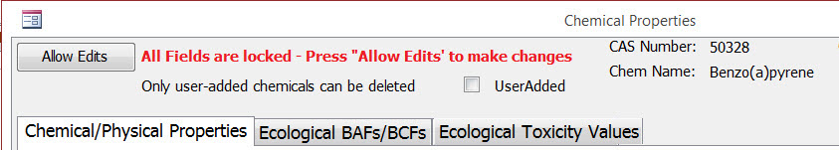
(B) Edit mode, built-in chemical
(C) View mode, user-added chemical (Delete Chemical button visible)
Figure 12. Chemical Properties screen header: in (A) View mode for a built-in chemical, (B) Edit mode for a built-in chemical, and (C) View mode for a user-added chemical (Delete Chemical button visible).
When you first open this screen, it will be in View mode (top of Figure 12): the data fields are locked to prevent accidental changes and cannot be edited. When the fields are locked, there will be an Allow Edits button and a red warning that the fields are locked in the upper left corner of the screen. If you just want to view the data, leave it in view mode. If you want to edit or add data, click on the Allow Edits button. This will place you in Edit mode (center of Figure 12); the Allow Edits button will no longer be displayed, and the red “All fields are locked” warning will be replaced with “Edits allowed – changes automatically saved” in green. The individual tabs showing the data you can edit are described below. All changes are saved immediately and automatically in Edit mode.
If the chemical you have chosen to view is a user-added chemical (bottom of Figure 12), the UserAdded checkbox below the locked message will be checked, and the Delete Chemical button will be displayed below the Allow Edits button. (For built-in chemicals, the Delete Chemical button is not displayed, and a message notes that only user-added chemicals can be deleted, as shown in the top and center panes of Figure 12). Click on the Delete Chemical button to delete the chemical completely from the database. The Tool will ask for confirmation; click Yes to delete (this cannot be undone) and close the Chemical Properties screen, No to keep the chemical and close the Chemical Properties screen, and Cancel to keep the chemical and remain on the Chemical Properties screen,
The chemical-specific data are organized into three tabs: Chemical/Physical Properties, Ecological BAFs, and Ecological Toxicity values. Each tab shows a list of properties, the current value, the units and allowable range, a comment, a checkbox indicating whether you have modified the value, and a reference. The references are a short citation; Section 7 contains a list of full citations for all references used in the database, sorted by this short citation. Note that human health toxicity values and reference ecological benchmark doses are found on the Chemical/Physical Properties tab, while concentration-based ecological toxicity values as well as receptor-specific benchmark doses for various mammal and bird species (for which there may be multiple receptors with different toxicity values) are found on the Ecological Toxicity values tab. The benchmark doses for mammal and bird receptors are scaled from the reference benchmarks in the Chemical/Physical Properties tab; see Appendix D for more details on ecological benchmark scaling.
Use the inner scroll bar on the right to scroll through the list of properties on a tab. Click in a box to change the value or comment. You can also tab through the entry fields. For each property, you can change the value (which may be entered in either standard or scientific notation) and add a comment. The comment is required and should note the source and any assumptions or surrogates of values for chemicals you have added or values you have changed. The User Modified check box under the range for each property will be checked if you change a value, for both built-in and user-added chemicals. This way, you can see if you have changed a value on a user-added chemical after adding it (e.g., if you change a calculated or default value). In addition, the reference will be changed to “User supplied.”
On all tabs, be sure to enter new values in the units shown—the units cannot be modified. If your source does not report values in the same units, you will need to convert the reported value to the units required by the Tool. Entering data that are not in the units shown will produce erroneous risk results. You must also enter a value within the range specified in the entry screen to the right of the value field. If you enter a value outside that range, it will be reset to the minimum or maximum and you will see a warning that this has been done. You can either leave the reset value or, if your entry was a typo and the minimum or maximum is not appropriate, you can correct it after clicking on OK to dismiss the warning.
If you have just added a new chemical and been brought to this screen, you will need to enter references (in the comments field) on the Chemical/Physical Properties and Ecological BAFs/BCFs tabs, and values and references on the Ecological Toxicity values tab.
Chemical/Physical Properties tab: This tab (Figure 13) shows chemical/physical properties (including aquatic degradation rates), BCFs/BAFs for human pathways, and human toxicity values in alphabetical order by the Model Code, which is a short property name (e.g., Henry’s law constant is alphabetized by HLC, its Model Code).
Uptake Factors
Please note that this User’s Guide is written for a varied audience and that the terminology used by environmental toxicologists continues to evolve. For these reasons this Guide uses BCF/BAF to include the multitude of approaches and computations used to quantify the movement of chemicals from a surrounding medium (air, soil, sediment, water) into living organisms. These may include bioaccumulation, bioconcentration, biomagnification, and biotransfer factors. A tiered approach is considered when using measured or modeled bioaccumulation, bioconcentration, biomagnification, and biotransfer factors.
If you change chemical/physical property values and then change your mind, click on the Reset Chemical Properties to Defaults button above the parameter list. This only resets values shown on this tab; the other tabs have their own reset buttons.
Terrestrial BCFs/BAFs (i.e., for plants and animal products) for organic chemicals are calculated based on the log K_{ow} (and HLC in the case of B_{v}, vapor air-to-plant uptake) if a value is available for log K_{ow} (and HLC for B_{v}). These BCFs/BAFs are denoted with an asterisk at the end of the parameter description, and a reminder of this appears next to the Reset Chemical Properties to Defaults button. If you change the values for either log K_{ow} or HLC, the Tool will ask if you want to recalculate these BCFs/BAFs. Click on Yes to recalculate them (this will overwrite any values you changed for the affected BCFs/BAFs), or No to skip recalculating if you feel this is not appropriate for the chemical in question or you have entered values from another source and do not want them overwritten. You will need to enter terrestrial BCFs/BAFs for any new chemical which does not have a log K_{ow}. If you change an existing log K_{ow} to a blank (or null) value (not zero, which is a valid value), the Tool will reset the terrestrial BCFs/BAFs for that chemical to zero, unless you have entered or modified the terrestrial BCF/BAFs values (in which case, the values you entered will not be overwritten).
Human toxicity values include cancer and noncancer toxicity values for oral and inhalation exposures, so a total of four possible toxicity parameters. However, a few chemicals (e.g., cadmium, manganese) have multiple oral noncancer toxicity values, or pathway-specific RfDs, instead of the typical single RfD used for all oral exposures. These pathway-specific RfDs are for water, soil, fish, food, or some subset of these. The Tool supports the use of either a general or pathway-specific RfDs for all chemicals. Near the top of this tab is a checkbox, which is enabled in Edit mode, that allows you to choose whether to display and use the single RfD for all ingestion pathways (checkbox unchecked) or the four pathway-specific RfDs (checkbox unchecked).
                - 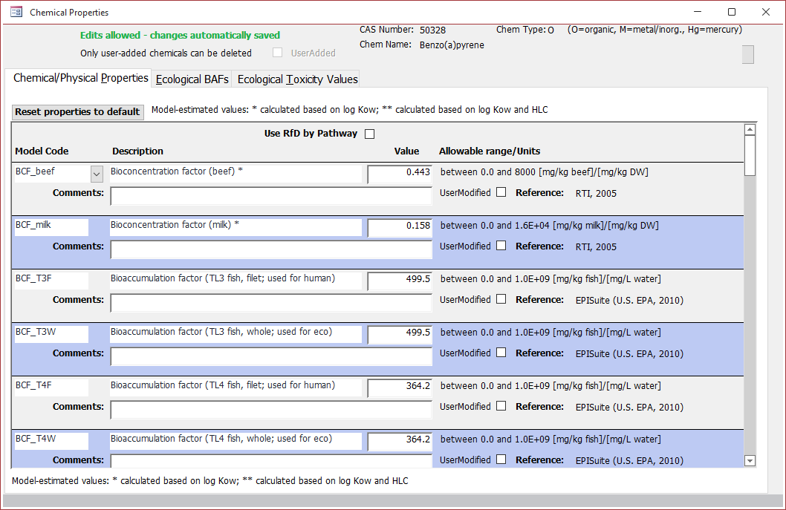
Figure 13. Chemical/Physical Properties tab.
Section 3.2.2, Add New Chemicals, has more information about many of the values shown on this tab. Additional information for all parameters shown in this tab except toxicity values, including the equations for calculating BCFs/BAFs for animal products, produce, and grains, may be found in Appendix C; more information on human toxicity values may be found in Appendix D.
Ecological BAFs tab: On this screen (Figure 14), you can edit existing ecological terrestrial and aquatic BAFs, as well as add new ones. The existing BAFs and BCFs are listed in alphabetical order by parameter name; to edit one, simply click in the value field and change the value. Enter the source in the comment field. To add a new one, use the inner scroll bar to get to the bottom of the list and select a type of BAF or BCF from the dropdown box under Model Code. Then enter the value in the value field and the source in the comment field. Section 3.2.2, Add New Chemicals, has more information about BCF/BAF values. Additional information may be found in Appendix C, Section C.5.
If you change BCF/BAF values and then change your mind, click on the Reset Properties to Default button above the parameter list. This only resets values shown on this tab; the other tabs have their own reset buttons. It does not delete or reset new BCFs/BAFs that you added.
                - 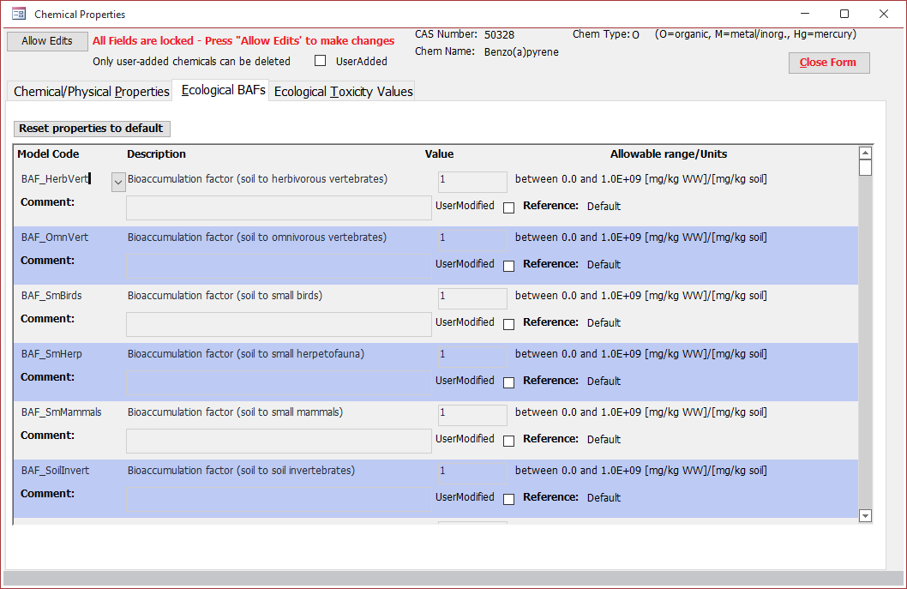
Figure 14. Chemical Properties window: view or edit ecological BAFs/BCFs.
Ecological Toxicity values tab: On this screen (Figure 15), you can edit existing ecological toxicity values and add additional receptors that do not currently have ecological toxicity values. Each type of receptor has an associated type of toxicity value:
- Birds and mammals have a benchmark dose (BMD); these are typically based on two reference BMDs and associated test species body weights, one for birds and one for mammals. The reference data may be added or edited on the Chemical/Physical Properties tab described above. If you add or change the reference data, the Tool will ask if you want to calculate new scaled species-specific values. You will need to have entered both the reference BMD and reference body weight, so you may want to select No after you change one if you are about to change the other. If you are entering data where there was none before, it will be able to calculate until you enter both values. However, the computation is very fast. The resulting scaled values for individual bird and mammal receptors are shown in this tab. However, you can override those scaled values in this tab by entering a different value.
- Soil community receptors have a benchmark concentration in soil (BMC_soil); these must be entered or edited here.
- Aquatic receptors (including amphibians) have a benchmark concentration in water (BMC_water); these must be entered or edited here. This benchmark also requires an exposure duration (ED_Eco), which is a separate record, to enable the Tool to use a water concentration averaged over the same time period. ED values are restricted to 1 day, 4 days, or 365 days, as these are the available averaging times for water concentrations in the Tool and the most common values associated with available BMC_Water values.
- Sediment community receptors have a benchmark concentration in sediment (BMC_sed); these must be entered or edited here.
To edit an existing toxicity values, simply click in the value field and change the value. When you leave the field, you will be prompted to enter a reference or other text documenting the source of the value; this will be saved in the comment field. If you do not enter something, the Tool will enter “No reference supplied” in the comments field. If you edit a BMC_Water, be sure to check (and edit if necessary) the associated ED_Eco value (this should be the record immediately below the BMC_Water record for the same receptor). Currently, the Tool can only accommodate one BMC_water/ED_Eco pair for a particular chemical and receptor at a time. If you want to do runs for different pairs for the same chemical and receptor, you will need to do separate runs, and edit the values in between.
                - 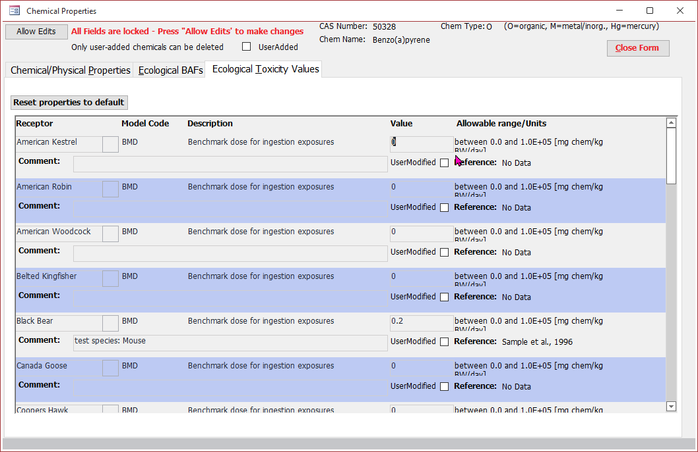
Figure 15. Chemical Properties window: view or edit ecological toxicity values.
To add a toxicity value for a receptor not already listed, click on the Add Receptor(s) for this Chemical button at the top of the form. This will open a dialog box with a dropdown from which you can select any receptor for which this chemical does not already have a toxicity value. Click on the Add Receptor button to add the receptor. The dialog box will remain visible, so you can add another receptor if desired. When you are done adding receptors, click on the Close button. You should now have one or two new records per new receptor, at the bottom of the list of receptors shown in Figure 15; receptors that use a BMC_Water will have two new records, one for the benchmark and one for the exposure duration and all others will have one new record, for the benchmark. These records are pre-populated with the receptor name, the toxicity value type, and a default value of 1 for the benchmark and, if applicable, 365 days for the exposure duration. You can then edit these default values to the desired values. Additional information on ecotoxicity values may be found in Appendix D.
If you change ecological toxicity values and then change your mind, click on the Reset Properties to Default button above the parameter list. This only resets values shown on this tab; the other tabs have their own reset buttons. It does not delete or reset new receptor-toxicity value combinations that you added. You can delete records for receptors you have added (but not records for receptors included with the Tool) by clicking on the red Delete button at the right edge of the tab by the record you wish to delete.
When you are done editing chemical data, click on the × in the upper right corner of the Chemical Properties form to close it; this will return you to the Chemicals tab of the Configure Model screen (Figure 9). Additional information may be found in Appendix C for physical-chemical properties and ecological BAFs/BCFs, and in Appendix D for toxicity values (both human and ecological).

3.2.4 Compare Non-default Properties for Selected Chemicals
You can compare the non-default (user-entered) chemical properties for the set of chemicals you have selected to include in a simulation. On the Chemicals tab, click on the View button under Compare Properties of Selected Chemicals (to the left of the list of chemicals; see Figure 8). Figure 16 shows an example of the Chemical Property Comparison window. In this example, only two chemicals were selected, but if more are selected, the display includes additional columns to the right for each chemical. While not all columns will show on the screen at once if you have more than a few chemicals selected, you can scroll over to view the data. You may find it easier to export comparisons for many chemicals to Excel; you can do that by clicking on the Export to Excel button under the View button. You will be prompted for a file name and location. The Excel file is structured the same way as the window shown in Figure 16, but also includes a second tab with the references for each property for each chemical where the value is shown in Figure 16.
                - 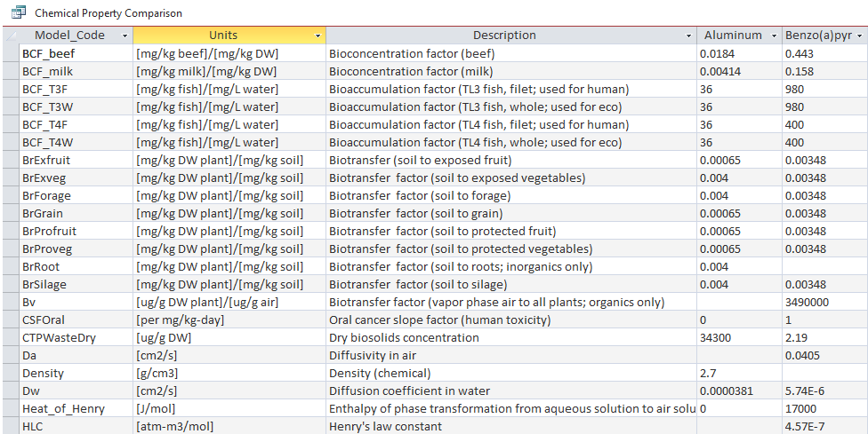
Figure 16. Chemical Property Comparison window.

3.3 Configure Human Exposure
Figure 17 shows the Human Exposure tab. The Tool estimates risk for two human receptors: an adult farmer and a farm child; these cannot be changed. The Tool includes 15 exposure pathways for LAUs and 3 for surface disposal units. For LAUs, some are applicable to all scenarios (crop, pasture, reclamation), and others are applicable only to particular scenarios. For convenience, the pathways are grouped into Pathways for All Scenarios, Additional Pathways for Crop Scenario, and Additional Pathways for Pasture/Reclamation Scenarios. The Human Exposure tab shows (and allows you to select) all pathways regardless of what scenario(s) you have chosen on the Scenarios tab; however, you will only get results for pathways that are applicable to the scenario(s) you have selected.
For surface disposal, the Tool runs only air, groundwater, and shower (unless one or more is deselected here).
                - 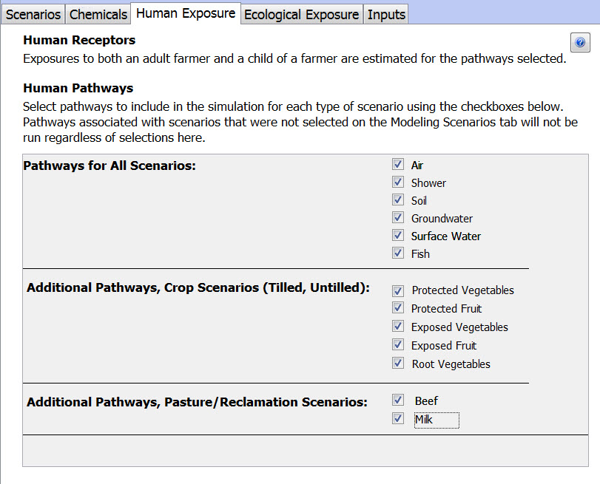
Figure 17. Human Exposure tab: Select one or more pathways to run.
In addition to the pathways shown in Figure 17, the Tool also calculates a total ingestion risk for each LAU scenario that sums the risks from all ingestion pathways selected that are applicable to the scenario (thus, it will vary depending on what pathways are selected, even if everything else stays the same). The total ingestion risk is based on groundwater as the source for drinking water and does not include risks from surface water ingestion, even if the groundwater pathway has not been selected and is thus not included in total ingestion. See Appendix A for more details. We strongly advise running all pathways, especially if you are interested in total ingestion risk; this does not impact run time.

3.4 Configure Ecological Exposure
Figure 18 shows the Ecological Exposure tab. Here, you can select receptors to run and edit diet fractions. The receptors are grouped into two categories: aquatic and terrestrial Aquatic receptors are those that live in waterbodies: amphibians, aquatic invertebrates, aquatic plant, fish, and sediment biota; the “aquatic community” receptor includes all of those more specific aquatic receptors and is typically used only when more specific receptor data are not available. Terrestrial receptors are those living on land. And include a variety of birds and mammals, as well as soil invertebrates and terrestrial plants.
                - 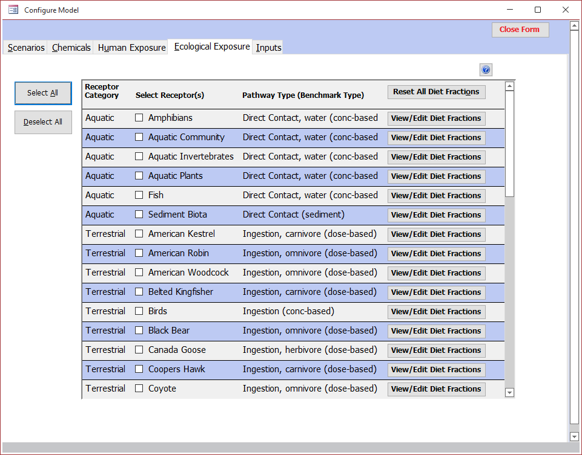
Figure 18. Ecological Exposure tab: Select one or more.
Click on the checkbox to the left of a receptor to select or deselect it. To select all receptors, click the Select All button on the left side of the tab. To deselect all receptors, click the Deselect All button. Use the scroll bar on the right to scroll through the entire list of receptors.
Unlike human receptors, which have multiple exposure pathways, the ecological receptors each have only one associated pathway. Following the receptor name is the pathway type relevant to that receptor, and whether the toxicity value is concentration or dose based. Receptors that are specific species of birds and mammals have ingestion toxicity values, while all others (including the general “birds” and mammals” receptors) have direct contact toxicity values.
For receptors with a dose-based toxicity value, the overall average diet is represented by a set of diet fractions for 20 potential dietary items. The default diet fractions are intended to be broadly representative and do not reflect any particular sex, life stage, or seasonality (consistent with the use of annual average media and prey concentrations). You can modify the default diet fractions by clicking on the View/Edit Diet Fractions button to the right of the pathway, as shown in Figure 19. (Diet fractions are not used for concentration-based toxicity values, so if you click on the View/Edit Diet Fractions button for one of those receptors, you will get a message saying diet fractions are not used instead of the form in Figure 19.) The View/Edit Receptor Diet form shows only the food items that might be eaten by the selected receptor; additional food items cannot be added. The dietary fraction for any food item may be set to zero, but the dietary fractions for all food items for a receptor must sum to 1, or you will get an error message when you try to close the form. Changes are saved immediately, so click on the × in the upper right-hand corner of the window to close the form. The user-modified flag cannot be edited; the Tool will automatically check it when you change a dietary fraction.
                - 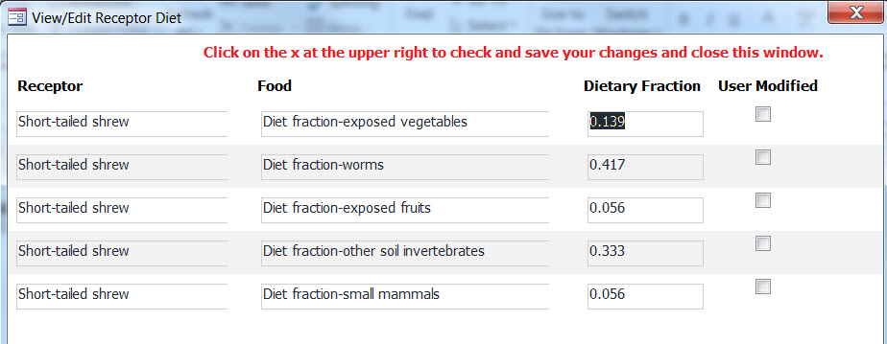
Figure 19. View/Edit Receptor Diet form.

3.5 View Inputs
The last tab on the Configure Model screen is the Inputs tab. Here, you can review all inputs as they are currently set and that the Tool will use for the next run if you run now. Many of these inputs cannot be directly changed. This tab contains seven sub-tabs (note that screen captures show inputs for an LAU only; for surface disposal, parameters and values may differ, but the layout is the same):
- Scenario: This sub-tab shows general inputs that vary by application scenario, such as tilling depth, or liner scenarios, for scenarios currently selected (Figure 20). These inputs cannot be modified.
- Fate and transport: This sub-tab shows general inputs that do not vary by application or liner scenario (Figure 21). Most of these inputs, except percent solids in land-applied biosolids, cannot be modified. Percent solids in land-applied biosolids can be modified on the Scenario tab of the Configure Model screen; percent solids in a surface disposal unit cannot be modified.
- Chemical: This sub-tab shows most chemical-specific inputs, including physical-chemical properties and human toxicity values (Figure 22). It does not include ecological toxicity values (those are on the eco toxicity tab) or ecological BAFs (those are on the eco BAFs tab). Because these values can be modified on the View/Edit Chemical form, the table includes a column called User Modified that is checked if the value has been changed.
- Human exposure: This sub-tab shows human exposure factor inputs, such as body weight, consumption rates, etc. (Figure 23). These inputs cannot be modified.
- Eco exposure: This sub-tab shows ecological exposure factors for the ecological receptors currently selected (Figure 24). Only the diet fractions can be modified, on the View/Edit Receptor Diet form. Note these inputs are only used for LAUs.
- Eco BAFs: This sub-tab shows ecological bioaccumulation factors for chemicals currently selected (Figure 25). Because these values can be modified on the View/Edit Chemical form, the table includes a column called User Modified that is checked if the value has been changed. Note these inputs are only used for LAUs.
Eco toxicity: This sub-tab shows ecological toxicity values for chemicals and ecological receptors currently selected (Figure 26). Because these values can be modified on the View/Edit Chemical form, the table includes a column called User Modified that is checked if the value has been changed. Note these inputs are only used for LAUs.
                - 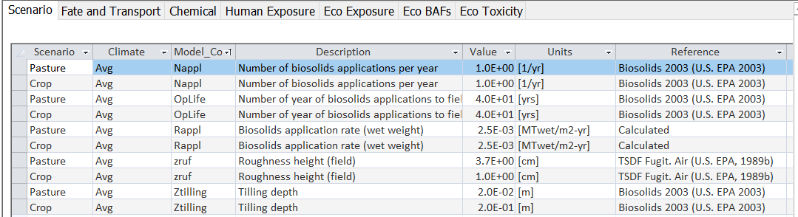
Figure 20. Inputs tab: Scenario inputs.
                - 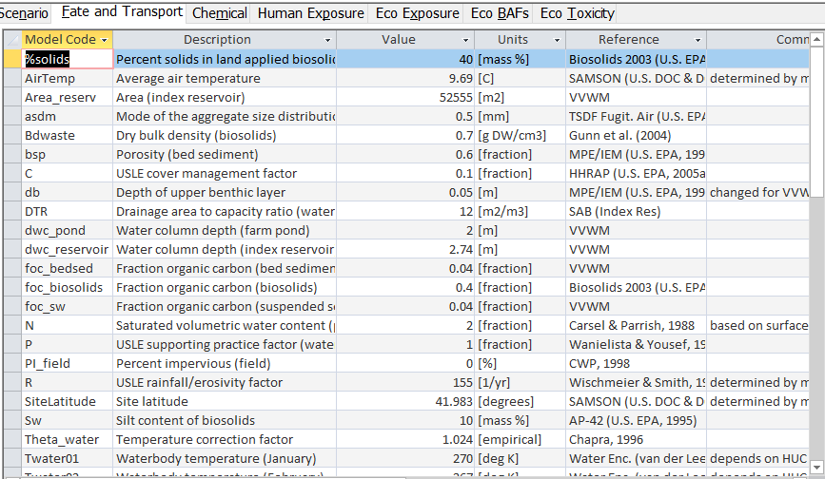
Figure 21. Inputs tab: Fate and transport inputs.
                - 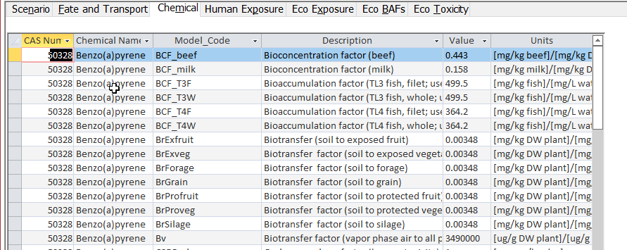
Figure 22. Inputs tab: Chemical inputs.
                - 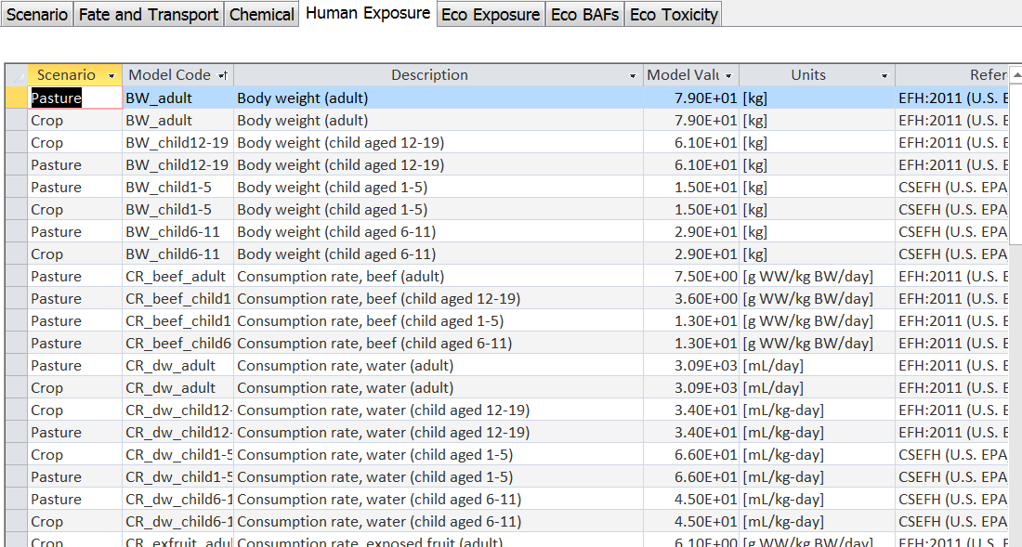
Figure 23. Inputs tab: Human exposure factors.
                - 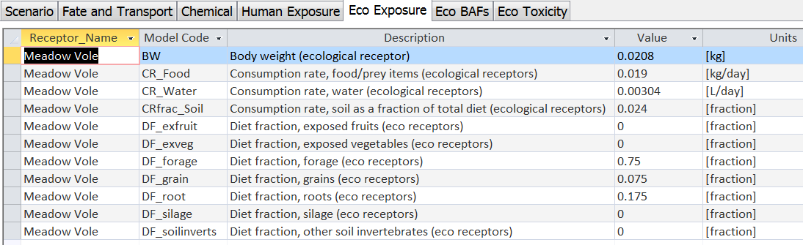
Figure 24. Inputs tab: Ecological exposure factors.
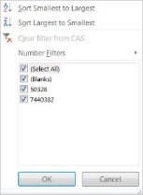
                - 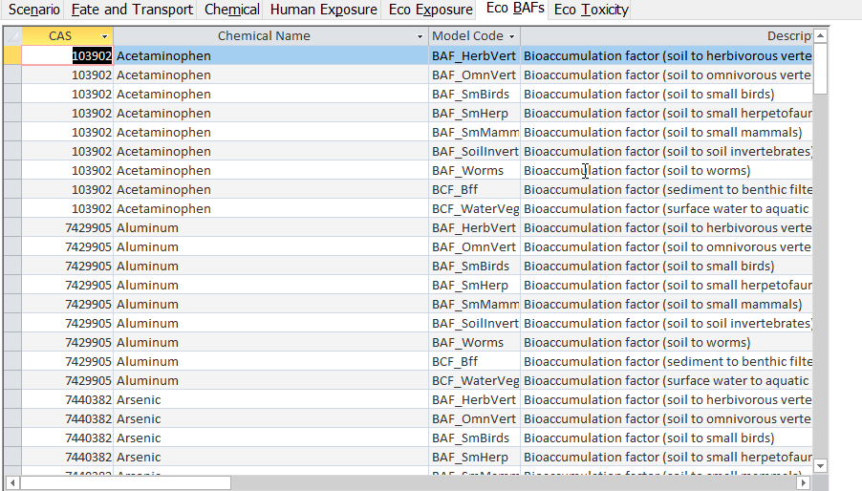
Figure 25. Inputs tab: Ecological bioaccumulation factors.
                - 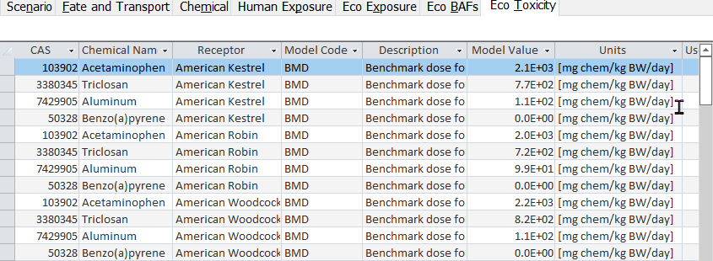
Figure 26. Inputs tab: Ecological toxicity values.
Inputs cannot be edited on these tabs. However, you can sort the table on any column by clicking on the column heading. You can also export the inputs on all seven sub-tabs by clicking on the Export to Excel button at the top of the Inputs tab. Section 7 includes a section with all references used in the Tool and the full citation for each.
When you are done configuring an analysis, click on the red Close Form button in the upper right corner, or on the × at the top right corner of the Configure Model window. This will return you to the Main Menu shown in Figure 6.
The derivation of input data are documented in the following appendices:
- Appendix B: Non-chemical-specific parameters
- Appendix C: Chemical-specific parameters
Appendix D: Human and ecological toxicity values.
Values are provided in Appendix B (non-chemical specific parameters) for convenience, as these values may not all be readily viewable in the Tool. However, all chemical-specific parameters, including toxicity values, are readily viewable in the Tool and for brevity, data are not provided here.

4. Run a Simulation
Run the simulation from the Main Menu (shown in Figure 5) by clicking the Run button. This immediately deletes all results from the previous run. The model executable will then ask you to confirm that you are ready to run the model. Click on the Yes button. the Biosolids Tool will now calculate high-end point estimates of hazard and risk for each of the scenarios, chemicals, pathways, and receptors selected during configuration.
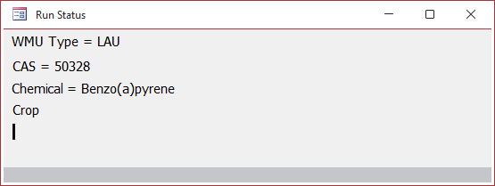
A status window (shown at right) will be displayed that will indicate the unit type, chemical, and scenario currently being run. LAU runs before surface disposal; chemicals run in CAS number order; LAU scenarios run in the order reclamation, pasture, crop; and surface disposal scenarios run in the order composite liner, clay liner, no liner.
The Tool takes about a minute to run one chemical for one LAU scenario and about 5–10 seconds for one chemical and one surface disposal unit liner scenario. Thus, the overall run time can vary significantly, depending on the number of units/scenarios and chemicals you select, as well as the speed of your computer. The number of human exposure pathways or ecological receptors does not have an appreciable impact on run time.
When the run is done, another window that says “Done!” will appear. Click on the Ok button to return to the Main Menu.
Appendix A provides technical background information on the calculations performed by the Biosolids Tool.

5. View, Export, and Save Results
Once a run is complete, view the results and input parameters used for the run by clicking on the View Results button on the Main Menu. This will open the Results window. When you are done viewing results, click on the × at the top right corner of the Results window to close it and return to the Main Menu shown in Figure 6.
Note that the Tool shows all results and inputs in a tabular format; graphical outputs are beyond the scope of the Tool (as well as the software used to implement it). However, all results and inputs can easily be exported to Excel (see Section 5.2). Once exported to Excel, you can create whatever graphs serve your specific needs, or save the data to a comma separated value file to import it into more sophisticated graphing software.

5.1 View Results
The Results window displays results separately for the LAU and surface disposal units. Buttons at the top of the Results window allow you to switch between LAU and surface disposal results. Figure 27 shows the top of the Results window for LAU results; the surface disposal window is essentially the same, except that the ecological results pane will always be empty, since ecological receptors are not modeled for the surface disposal unit. Depending on your display settings, you may need to make the Results window bigger to see all columns.
                - 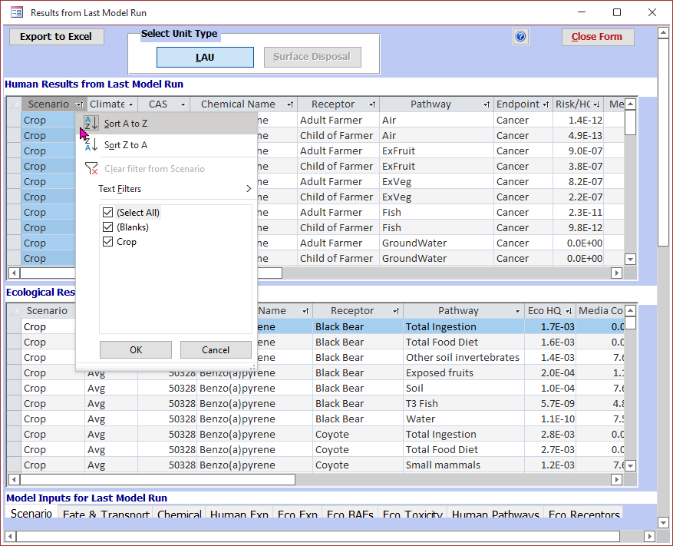
Figure 27. Results window showing LAU results.
The Results window includes three tables: human results, ecological results, and model inputs.
The tables for human Results and ecological results are shown in Figure 27. The results can be sorted or filtered by clicking on the column headers, as illustrated in Figure 26, which shows the drop down for sorting or filtering human results by scenario. Note the Ecological Results table will be empty for LAU if no ecological receptors were selected, and is always empty for surface disposal, as ecological receptors are not modeled.
These tables show the following information:
- Scenario: for LAU, this is crop, pasture, reclamation (all may be selected for a run); for surface disposal, liner type.
- Climate: dry, average, wet (only one may be selected for a run)
- CAS Number and Chemical Name (one or more may be selected for a run)
- Receptor: for human results, either Adult Farmer or Child of Farmer; for ecological results, results for all selected receptors will be shown.
- Pathway: the exposure pathway. You will only see pathways you selected, plus total ingestion for LAU. Note that total ingestion will only include ingestion pathways selected. The pathways are named for the exposure medium (e.g., air, exposed fruit). The surface disposal results include only one ingestion pathway (groundwater), thus total ingestion is the same as groundwater.
- Endpoint (human only): either cancer and noncancer; if a chemical has both types of health toxicity value, results are calculated for both and they appear on separate rows.
- Risk/HQ: if the endpoint is cancer, this is a risk; if it is noncancer, this is an HQ. All ecological results are HQs. A zero value may indicate one of two things: (1) that the media concentration was so low that it was truncated to zero by the underlying computational model (this happens a lot with groundwater) or (2) that the BCF/BAF for this pathway is missing or zero. This latter case would be indicated by a value of “missing” in the BCF/BAF warning column (see below).
- Media Concentration and Concentration Units: the media concentration used to calculate the risk or HQ, along with the units. The pathway identifies the medium associated with this concentration. So, if the pathway is “ExFruit” (exposed fruit), then the media concentration is the concentration of the chemical in exposed fruit. Note that the total ingestion pathway risk or HQ has no associated media concentration, because it is the sum of the individual ingestion pathway risks or HQs (and so, based on the media concentrations for all of those).
Warning: for human results, this may display various warnings or be blank (if there are no warnings). Warnings that may be displayed here include:
- Solubility limit exceeded: For LAUs, this warning indicates that the solubility in soil porewater was exceeded in the LAU source model. The LAU model does not cap the porewater concentration at the solubility, but completes the run with the concentrations as calculated, but the results should be used with caution. This typically only occurs for constituents with very, very low solubilities when the application rate has been set to or near the high-end values.
- BCF/BAF bounded low (or high): For organics, this warning indicates that the log K_{ow} used to estimate the BCF/BAF fell outside the applicable range of the correlation equation used, so the log K_{ow} was bounded at the corresponding end of the applicable range of log K_{ow} before estimating the BCF/BAF. For example, the correlation equation for estimating soil to above-ground crop uptake (Br) has a valid log K_{ow} range of 1.15 to 9.35; the Br for a constituent with a log K_{ow} of 1 would be estimated based on the low end of the log K_{ow} range (log K_{ow} = 1.15) and be flagged as “bounded low”. The “low” or “high” designation refers to the input parameter (log K_{ow} or, for air-to-plant transfer [Bv], HLC), not the resulting BCF/BAF. The different BCFs/BAFs have different relationships to log K_{ow} (or HLC): for soil to root vegetable uptake, the root concentration factor (RCF) increases as log K_{ow} increases; Br decreases as as log K_{ow} increases; Bv increases as log K_{ow} increases and decreases as HLC increase; and finally, the BCFs/BAFs for beef and milk increase as log K_{ow} increases from -0.67 (the lower end of the valid range) to 5, then decreases as log K_{ow} increases from 5 to 8.2 (the upper end of the valid range)..
- BCF/BAF estimated: for organics for the fish pathway, this warning indicates that the fish BCF was estimated using EPISuite, rather than based on data. Data-based values are always preferred if available.
- BCF/BAF is surrogate: for the fish pathway, this warning indicates that a fish BCF/BAF was available for only one trophic level (rather than both) and was used for both, or that fish BCFs/BAFs were available only for whole fish and those were used for filet for human consumption.
- BCF/BAF missing: for inorganics for the fish pathway, this warning indicates that no data were available for fish BCF/BAF. EPISuite cannot be used to estimate properties for inorganics, so missing fish BCFs/BAFs cannot be estimated as they are for organics. This warning may also appear for inorganics for plant, beef, or milk pathways, where it also indicates that no BCF/BAF is available for that pathway. Missing plant or animal BCFs/BAFs cannot be estimated from log K_{ow} as they are for organics.
The first six tabs of the Model Inputs section of the Results window are laid out identically to those shown in Figures 20–26 so are not repeated here. However, on the Chemical Inputs tab on the Results screen, parameters with missing values are displayed in red, to make it easier to see them and determine what impact the missing data might have on the results. For example, if both the RfC and IUR are missing for a chemical, there will be no air results for that chemical. In addition, the Model Inputs section of the Results window includes two tabs to document the human pathways and ecological receptors selected for the run; these are not included in the Inputs tab in the Configure Model window, because these choices can be viewed on the Human Exposure and Ecological Exposure tabs of the Configure Model window (see Figures 16 and 17).
IMPORTANT! The Model Inputs tabs in the Results window and the Inputs tabs in the Configure Model window are laid out the same way, but may not contain the same values:
The Model Inputs tabs in the Results window reflect the inputs used in the most recent model run (so the input values associated with the results shown).
The Inputs tabs in the Configure Model window reflect the latest changes to the inputs, which may not have been run yet.
Immediately after a run, these two sets of Inputs tabs will have identical content. However, as soon as you go back to the Configure Model window and revise any inputs, including chemical selections, those changes will be reflected in the Inputs tab of the Configure Model window, but they will not be reflected in the Inputs table on the Results window until you rerun the model.

5.2 Export Results and Associated Inputs
You can export the results and associated inputs by clicking on the Export to Excel button at the top left of the Results window (see Figure 27). Note that this exports only the results and inputs for the selected unit type (LAU or SI). To export both, you will need to export two files, one from each screen.
You will be prompted for a file name via a standard Windows file save dialog; you can browse to the desired location (it defaults to the folder where you installed the Tool) and select a file name. The resulting Excel file will have twelve sheets corresponding to the two results tabs (human and ecological), the seven inputs tabs, two pathway/receptor selection tabs, and a reference list containing full citations for all references. Figure 28 shows a sample export file. Access exports the file with all sheets selected; when you open it, you will need to select a single sheet before many menu options in Excel are available.
                - 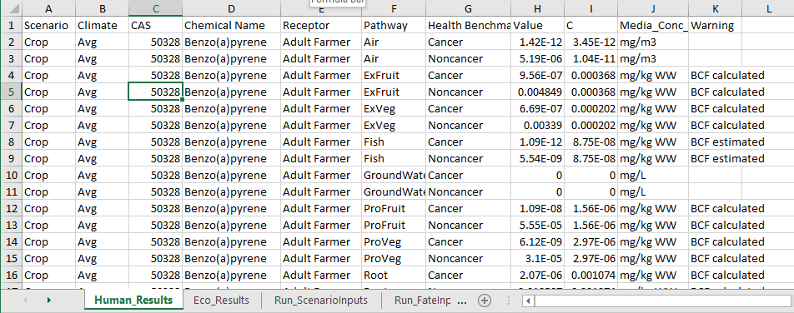
Figure 28. Sample export file.

5.3 Save a Run
As noted earlier, any configuration changes you make are automatically saved in the underlying Biosolids Tool database (BST_v2022xxxx.mdb), including changes to selected scenarios, chemicals, pathways, and receptors and any changes you make to percent solids or chemical-specific inputs. The next time you run the Tool, those settings will be the starting point for any configuration changes you might then make. Thus, the most recent configuration and run results are automatically saved. However, there may be instances in which you want to save a particular configuration and reload and revise it. That cannot be done directly, but it can be done indirectly if you prepare for doing so BEFORE you set up the configuration you want to save:
- Make a copy of BST_v2022xxxx.mdb file and rename it to reflect the desired configuration (e.g., BST_arsenic_baseline.mdb)
- Open this new file instead of the installed file and revise the settings to the desired configuration. Changes will be automatically saved in the renamed copy.
If you want to save a series of variations on a configuration, you can repeat the above process using either the original file each time or a copy you have already made as a starting point. For example, if you want to save three variants of a run for arsenic, reflecting preloaded, low, and high values for the various BCFs/BAFs, make an initial copy (e.g., BST_arsenic_baseline), set that up to run arsenic in the desired pathways with the preloaded chemical data, then make two additional copies of the BST_arsenic_baseline file (e.g., BST_arsenic_BCFsBAFs_low and BST_arsenic_BCFsBAFs_high), open these, and make only the changes to the BCFs/BAFs. You can then open each of these three files, run them, and export the results while maintaining a revisable version of each configuration.
Note that the new file name can be anything, but copies must be located in the same folder as the installed Biosolids Tool to run. You can save the files and open them to revise the configuration in another location, but the model will not run from another directory.

6. Limitations
The BST currently evaluates human health risks to a farm family, and ecological risk to aquatic and terrestrial organisms from land application and surface disposal of biosolids. There are some limitations of the tool as currently designed.
Additive risk, mixtures: The Biosolids Tool is not designed to consider potential dose additivity across chemicals (e.g., chemicals with similar target organs or endpoints). This is in keeping with its status as a model to support (chemical-specific) concentration-based regulation. The BST cannot currently accommodate a toxicity equivalent (TEQ) approach to sets of chemicals with similar modes of action.
Biological hazards: The BST includes algorithms only for chemical risk assessment to inform concentration-based standards and cannot model pathogens or other biological agents such as parasite eggs, oocysts, spores, prions, and antibiotic resistance genes. The methods for microbial risk assessment are quite different from those for chemical risk assessment; in addition, pathogens in biosolids are currently regulated using operational standards rather than concentration-based standards
Chemical limitations: The chemical risk assessment algorithms in the BST have certain limitations. These include chemicals that cannot be appropriately modeled as well as chemicals that can be modeled but may have greater uncertainty around the results. The BST model algorithms do not simulate dioxin-like compounds or mercury speciation adequately and this tool should not be used for these compounds.
- Dioxin-like compounds: The fate and transport of these types of chemicals is typically modeled somewhat differently from other organics. For example, estimating fish concentration from surface water concentration for most pollutants involves applying a bioaccumulation factor/bioconcentration factor (BAF/BCF) to the dissolved water concentration. A tiered approach is considered when using measured or modeled bioaccumulation, bioconcentration, biomagnification, and biotransfer factors. For dioxin-like compounds, it involves applying a biota-sediment accumulation factor to the total (not just dissolved) water column concentrations. Another example is how risks are calculated: typically risks for dioxin-like compounds are estimated collectively using a single toxicity value (for 2,3,7,8-tetradibenzo-p-dioxin) and a series of toxicity equivalence factors that express the concentrations for the other congeners in terms of equivalent 2,3,7,8-TCDD concentration, given the relative toxicity values. The BST does not contain the appropriate algorithms or data to support these calculations, and dioxin-like compounds in biosolids have already been evaluated in greater detail than is reflected by the tool (U.S. EPA, 2003a).
- Ionizable compounds: The BST uses certain empirical relationships to estimate some chemical properties for organics (e.g., K_{oc}, various terrestrial bioconcentration factors); these relationships introduce uncertainty for some categories of chemicals, such as ionizable compounds. Although the BST may be parameterized with some of these chemicals, and can be used to model them, there is greater uncertainty associated with the results. EPA encourages you to update these estimated parameter values with reported data from peer-reviewed literature when available to reduce uncertainties.
Precursors and transformation products: The Tool cannot simulate chemical transformation to evaluate formation of chemicals from precursors or breakdown of chemicals to more toxic daughter products. However, you can add chemicals, providing the ability to model the resulting products.

7. References
[Note that the appendices have individual reference lists; this list applies to the main User’s Guide.]
U.S. EPA (Environmental Protection Agency). 1992. Technical Support Document for Land Application of Sewage Sludge. Volume I. EPA 822/R-93-001a. Office of Water, Washington, DC. November.
U.S. EPA (Environmental Protection Agency). 2003a. Technical Background Document for the Sewage Sludge Exposure and Hazard Screening Assessment. U.S. EPA, Office of Water, Washington, DC. EPA-822-B-03-001. December 19.
U.S. EPA (Environmental Protection Agency). 2003b. Multimedia, Multipathway, and Multireceptor Risk Assessment (3MRA) Modeling System. Volume I: Modeling System and Science. SAB Review Draft. Office of Research and Development (Athens, GA) and Office of Solid Waste (Washington, DC). July.
U.S. EPA (Environmental Protection Agency). 2005. Human Health Risk Assessment Protocol for Hazardous Waste Combustion Facilities. EPA/530/R-05/006. U.S. EPA, Office of Solid Waste and Emergency Response. September. Washington, DC.
U.S. EPA (Environmental Protection Agency). 2009a. Targeted National Sewage Sludge Survey Sampling and Analysis Technical Report. EPA-822-R-08-016. Office of Water, Office of Science and Technology, Washington, DC. Available at http://water.epa.gov/‌scitech/‌wastetech/‌biosolids/‌biosolids_index.cfm.
U.S. EPA (Environmental Protection Agency). 2009b. Targeted National Sewage Sludge Survey Statistical Analysis Report. EPA/822/R-08/018. Office of Water, Office of Science and Technology, Washington, DC. Available at http://water.epa.gov/scitech/wastetech/biosolids/‌biosolids_index.cfm.
U.S. EPA (Environmental Protection Agency). 2010. Estimation Programs Interface Suite (EPISuite) for Microsoft Windows, v 4.10. Washington, DC: U.S. Environmental Protection Agency. September.
U.S. EPA (Environmental Protection Agency). 2011. Exposure Factors Handbook: 2011 Edition. EPA/600/R-090/052F. National Center for Environmental Assessment, Office of Research and Development, Washington, DC. September. Available at http://www.epa.gov/ncea/efh/pdfs/efh-complete.pdf.
U.S. EPA (Environmental Protection Agency). 2021. Targeted National Sewage Sludge Survey: Summary Statistics and Estimates of 95th Percentiles for 84 Additional Analytes. EPA 822-R-21-003. EPA Office of Water, Washington, DC. April.

Chemicals that have been detected in biosolids or sewage sludge during literature reviews may not have sufficient data to establish a 95% concentration for the nation. The source data will need to be evaluated by chemical to estimate a high-end concentration for screening risk assessment.
Click on the Office button or File Menu, select Options, Trust Center, Trust Center Settings, Trusted Locations, Add New Location. Browse to the location where you saved the Tool, click Ok, make sure you check Subfolders Also Trusted, then click Ok until you are returned to the database. The next time you open it, you should no longer get the warning.
When using EPISuite to estimate parameter values, be sure to enter any properties data you do have so that the estimated property value will be consistent with the data you have, and always select the “Full Results” option.
The generic receptors “birds” and “mammals” are based on Ecological Soil Screening Levels (Eco-SSLs; see https://www.epa.gov/chemical-research/ecological-soil-screening-level), which are based on soil concentrations.

